JROTC
FIRST LIEUTENANT
EXAM STUDY GUIDE
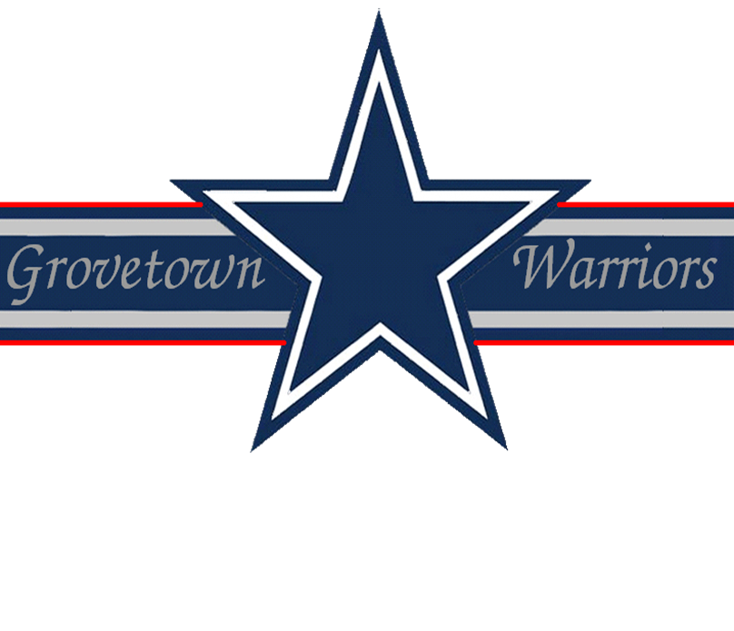
Drill & Ceremonies
1. What command is given for marching backwards?
BACKWARD, MARCH.
2. How many counts does it take to move from order arms to inspection arms?
Seven.
3. What body position is assumed on the command STAND AT, EASE?
On the command of execution, EASE, execute parade rest, but turn your head and eyes to the individual giving the command.
4. What is the difference between interval and distance?
- Distance is the space between elements when the elements are one behind the other
- Interval is the lateral space between soldiers or elements in a formation, measures from left to right
5. Why do we have drill and ceremony?
To move units or individuals in a uniform manner with precision, to instill discipline and esprit de corps, to render honors, and to preserve tradition.
6. What are the seven parts of review?
- Formation of the troops
- Presentation and honors
- Inspection
- Honors to the nation
- Remarks
- March in review
- Conclusion
7. What command is given to retrieve stacked arms?
TAKE, ARMS.
8. How do you change a line formation to a column formation?
Give the command RIGHT, FACE.
9. In which directions, for short distances only, may the unit commander have the unit move in a designated number of steps?
Forward or backward or sideways.
10. What is meant by the term "inflection"?
The rise and fall in pitch of the voice of the individual giving commands.
First Aid
1. How is arterial bleeding recognized?
Spurts of bright red blood.
2. Describe the appearance of bleeding from a vein.
Dark red and a steady flow.
3. In an emergency situation what is the choice method for controlling the bleeding?
The use of the pressure dressing.
4. Give five uses of dressings.
- Control bleeding
- Apply medication
- Absorb excess moisture
- Conserve local heat
- Protect the wound
5. What are the four types of burns?
- Thermal burns
- Electrical burns
- Chemical burns
- Laser burns
6. What are the five steps in treating a blister?
- Wash the area with soap and water
- Sterilize a needle by heating until red
- Puncture the outside edge as close to the lower edge as possible
- Roll the needle from the top edge to the bottom edge draining the blister of any fluid
- Apply and secure a compress dressing
7. What is "self aid in relation to the Armed Forces"?
The emergency treatment one applies to oneself.
8. What are the signs of dehydration?
Dark yellow urine, sluggish, no appetite, nausea, drowsy, higher temperature, dizzy and dry mouth.
9. What are the symptoms of heat stroke?
Clammy skin, does not perspire, hot and dry skin, extreme high temperature, unconsciousness nearly always results.
10. What are two types of wet weather injuries and how would you prevent them?
- Immersion foot: exposure to dampness and heat; change socks daily (between changing allow 5 minutes for air to get to feet) and keep moisture out of footgear
- Trench foot: exposure to dampness and cold; treatment is the same as above
11. What are the signs of deep frostbite?
Numbness and skin appears yellowish or waxen "wooden" or solid to the touch.
12. What is trench foot?
Trench foot is when the feet are exposed to wet conditions, generally at temperatures from freezing to 50 degrees F., and the feet are inactive for a long period of time..
13. Name four principles to remember in psychological first aid.
- Respect everyone’s right to have his own feelings
- Accept emotional disability as being just as real as physical disability
- Realize that every physically injured person has some emotional reaction to the fact that he/she is injured
- Realize there is more strength in most disturbed soldiers than appears at first glance
14. What is rabies?
Rabies is a disease of warm-blooded animals transmitted to humans by bites and scratches.
15. How do you treat a casualty for a severe electrical shock?
Treatment for severe electrical shock is to turn off the power, if possible; use a dry wooden pole or any other non-conductive material to remove the casualty from the live wire; administer artificial respiration, if required; and send for medical aid.
Flags, Guidons, Streamers, Automobile and Aircraft Plates
1. Where can the National Flag be flown at night?
As of 1966 the National Flag is flown at night by special legal authority in the following places:
- US Capital - Washington, D.C.
- Fort McHenry - National Monument
- Historical Shrine, Flag Square - Baltimore, MD
- Francis Scott Key’s grave
- World War Memorial - Worchester, MA
- Moon
- Tomb of the Unknown Soldier
2. How is the National flag disposed of when worn out?
When a flag is no longer suitable for display, it will not be cast aside or used in any way that may be viewed as disrespectful. If not preserved, it will be destroyed privately, preferably by burning or by some other method which lacks in any way irreverence or disrespect to the flag.
3. Who is responsible to ensure that National Flags on display are presentable?
Commanders.
4. After the flag has been lowered, (for retreat) how is it folded?
Never let it touch the ground and folded into a triangle with the union up (known as the cocked hat).
5. What are some of the legal holidays when the Garrison Flag is displayed (weather and military operations permitting)?
- New Year’s Day (1 January)
- Washington’s Birthday (22 February)
- Memorial Day (30 May)
- Independence Day (4 July)
- Labor Day (lst Monday in September)
- Columbus Day (2nd Monday in October)
- Veterans Day (11 November)
- Thanksgiving Day (4th Thursday in November)
- Christmas Day (25 December)
6. What is the difference between a Flag, Colors, and a Standard?
- The Flag is the emblem of our country and displayed on flag poles at Post and other Headquarters authorized to display them
- The Colors is the flag when carried in formation by dismounted troops
- The Standard is the flag when carried in formation by mounted or mechanized troops
7. What is the birthday of the US Flag?
14 June 1777.
8. When and by whom was the US Army Flag approved?
12 June 1956, by Executive Order 10670. It is the senior flag of the US Army.
9. When are Guidons displayed?
Guidons will be carried by units participating in parades and reviews or displayed as directed by the Commander.
10. How many personnel are required by a detachment or separate platoons in order to have a guidon?
20 or more military personnel.
Leadership Counseling
1. What is the definition of counseling?
A process of listening, communicating advice, instruction, or judgment with the intent of influencing a person’s attitude or behavior.
2. What are the reasons for counseling?
Reception and Integration, Discipline, Performance, Professional Growth and Guidance, and Personal.
3. What are the four learning steps an individual must take to further develop his counseling skills?
- The leader as counselor
- Approaches to counseling
- Counseling skills and procedures
- The art of communicating
4. What type of personal counseling is most effective?
Personal counseling which encourages the person to arrive at their own solution.
5. During a counseling session, should the leader spend more time at talking or listening?
A counselor should listen more than he speaks with emphasis on making comments or responding by asking questions as necessary.
Map Reading
1. What is a map?
A map is a graphic representation, drawn to scale, of a portion of the earth’s surface.
2. Why is it necessary to learn to read a map?
- To assist in locating and determining exact locations
- To assist in maintaining direction
- To assist in determining routes to follow
3. What colors are used on military maps?
- Blue: water
- Green: vegetation
- Red-Brown: cultural features, all relief features, and elevation
- Red: main roads and populated areas
- Black: man-made objects
- Brown: relief features & elevation
4. What does the color yellow represent on an overlay?
A contaminated area.
5. What is the declination diagram?
A numerical scale. Indicates the relationship map to ground distance.
6. What is meant by the scale of a map?
Scale is expressed as a fraction and gives the ratio of map distance to ground distance.
7. What are the symbols for the three norths?
- Magnetic: Arrow
- True: Star
- Grid: Vertical Line
8. What is the legend of a map?
Illustrates and identifies the topographic symbols used to depict the more prominent features of the map.
9. Are the legend symbols always the same on every map?
No.
10. What is a military symbol?
Graphic aids which accurately identify items of operational interest.
Military Courtesy
1. When riding in a military vehicle and the National Anthem or "To the Colors" is played, what action should be taken?
Stop the vehicle and the senior person in the vehicle should dismount and salute; the other personnel should remain in the vehicle seated in the position of attention.
2. Who enters a military vehicle first?
The junior member enters first and others follow order of rank; the driver enters last.
3. When a person is running and encounters a situation where a salute is required, what should the individual do?
- Halt if the flag is involved and then salute
- Walk if an officer’s presence requires rendering of honor
4. What was the original purpose of retreat?
Retreat has always been at sunset and its purpose was to notify sentries to start challenging until sunrise and to tell the rank and file to go to their quarters and stay there.
5. What does the guidon placed in front of the orderly room indicate?
The guidon placed in front of the orderly room indicates that the unit commander is in and designates the unit.
6. What is "To The Colors?"
"To The Colors" is the Old Cavalry Call "To the Standard", in use from about 1835.
7. How many volleys are fired over the grave at a military funeral and why?
Three volleys are fired over the grave at a military funeral. The custom dates back to old Roman customs of saying farewell three times to their dead soldiers.
8. What should you do when approaching an officer while double-timing alone?
If you approach an officer while you are double-timing alone, assume quick time march and render the hand salute. When the salute is returned, execute order arms and resume double-timing.
9. What should accompany a salute?
The salute should be accompanied with an appropriate greeting, such as, "Good morning/afternoon, sir/ma’am."
10. When is saluting not required?
- Indoors, except when reporting to an officer or when on duty as a guard.
- When a prisoner
- When it is obviously inappropriate (officer has articles in his/her hands or otherwise occupied)
Military History
1. What is the date 7 December l941 known for?
The Japanese unprovoked attack at 0730 hours on Pearl Harbor.
2. Who said "I shall return" and where?
General Douglas MacArthur in the Philippines.
3. When and where was the US-ROK Status of Forces Agreement signed?
On 9 July 1966 in Seoul, Korea.
4. What does SOFA stand for?
Status of Forces Agreement.
5. Where is Headquarters FORSCOM located?
It is located at Fort McPhearson, Georgia.
Military Leadership
1. What is military leadership?
Military leadership is the process of influencing others to accomplish the mission by providing purpose, direction, and motivation.
2. What are the basic responsibilities of a leader?
Accomplishment of the mission and the welfare of the soldiers.
3. What is the Professional Army Ethic?
- Loyalty to the nation, the Army, and the unit
- Duty
- Selfless service
4. How can a leader stop the spread of a rumor?
Give the troops as many facts as possible with security requirements and attempt to eliminate conditions
5. What is tact?
It is a sensitive perception of people, their values, feelings, and views which allows positive interaction..
6. Define the word "proficiency" as it applies to military leadership?
The technical, tactical, and physical ability of the individual and the unit.
7. What are formal norms?
They are official standards or laws that govern behavior.
8. What four emotions must you, as a leader, inspire in yourself and your soldiers that will combat fear, panic and stress?
Confidence, purpose, meaning, and self-respect.
9. What is communication?
It is the exchange or flow of information and ideas from one person to another.
10. What are the two types of authority?
Command authority and general military authority.
Physical Fitness
1. What groups of soldiers may need special fitness programs?
- APFT failures who do not have medical profiles
- Overweight personnel according to AR 600-9
- Those who have permanent or temporary profiles
2. Who is responsible for training the event supervisors, scorers, and demonstrators for the Army Physical Fitness Test (APFT)?
The OIC or NCOIC.
3. Who makes rulings on questions or scoring for each event in the APFT?
The event supervisor.
4. What does the push-up measure?
Endurance of the chest, shoulder, and triceps muscles.
5. If a mat is used for the push-up or sit-up event on the APFT, what should the scorer observe?
That the entire body is on the mat.

