JROTC
SECOND LIEUTENANT
EXAM STUDY GUIDE
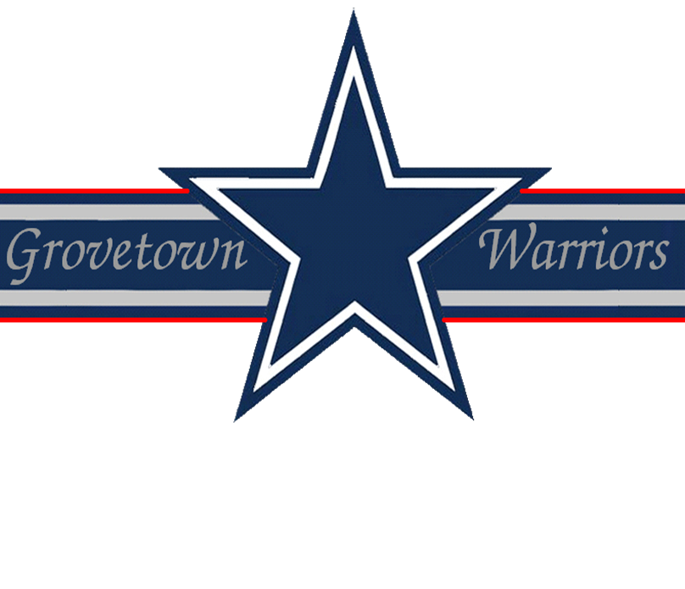

Drill & Ceremonies
1. What are the commands for the two rest movements while marching?
AT EASE, MARCH and ROUTE STEP, MARCH.
2. Why do we have drill and ceremony?
To move units or individuals in a uniform manner with precision, to instill discipline and esprit de corps, to render honors, and to preserve tradition.
3. How do you close ranks?
On the command close ranks, march, the first rank takes four 15 inch steps to the rear, the second rank takes two 15 inch steps to the rear, the third rank remains in place, and the fourth rank takes one 30 inch step forward.
4. What is meant by the term "post"?
Post refers to the correct place for an officer or noncommissioned officer to stand in a prescribed formation.
5. What is meant by the term "guide"?
"Guide" refers to the person responsible for the prescribed direction and rate of march.
6. What are supplementary commands?
Oral orders by a subordinate leader that reinforce and complement a commander’s order which ensures proper standing and execution of a movement.
7. How would you dismiss a company formation of armed troops?
Give the commands:
- INSPECTION, ARMS
- READY, PORT, ARMS
- SLING, ARMS
- ORDER, ARMS
- DISMISSED
8. What command do you give when changing direction and a column movement is not applicable?
INCLINE AROUND LEFT (RIGHT).
9. At what position does a squad stack arms?
In a line formation at normal interval.
10. What is meant by the term "cover"?
"Cover" is aligning yourself directly behind the man to your immediate front while maintaining correct distance.
11. What is a rank?
A line which has only one element in depth.
12. If a ranking officer enters the mess hall, what action do you take?
Call AT EASE and remain seated.
13. During "MARK TIME", how many inches should the feet be lifted?
Two inches.
14. How many steps are in half step and how long are the steps?
120 steps per minute with a 15 inch step.
15. What is a step?
The measured distance from heel to heel of a marching element.
First Aid
1. Why is individual training in first aid of such a great importance?
In the event of an emergency, medical personnel may not be readily available.
2. What are the four life-saving measures in order?
1. Open the airway and restore breathing and heartbeat
2. Stop the bleeding
3. Protect/treat the wound
4. Treat for shock
3. What military publication covers first aid?
Field Manual 21-11.
4. What is the principal danger of small wounds such as cuts and scratches?
Infection from contamination as these wounds bleed very little.
5. What are the two types of fractures?
- Compound or open fracture (bone through the skin)
- Simple or closed fracture
6. What are the signs of carbon monoxide poisoning?
Headache, dizzy, yawn, nausea, ears ring and heart flutters.
7. When treating for or trying to prevent shock, you are suppose to give the casualty, provided he is awake and does not have a belly wound, a stimulant. Would you consider alcohol a stimulant?
No, it’s a depressant.
8. What first aid measures should be given to a person suffering from heat stroke?
- Move the casualty to a cool, shady area of improvised shade and loosen his clothing
- Immerse him in cool water, if he cannot be immersed, the arms and legs should be massaged with cool water, pour water on him and fan him
- If conscious have him slowly drink at least one canteen full of water
- Seek medical aid and evacuate as soon as possible
9. What are two types of wet weather injuries and how would you prevent them?
- Immersion foot: exposure to dampness and heat; change socks daily (between changing allow 5 minutes for air to get to feet) and keep moisture out of footgear
- Trench foot: exposure to dampness and cold; treatment is the same as above
10. Where should a deep frostbite be treated?
At the aid station.
11. How do you treat superficial frostbite?
Warm at body temperature, hands on cheeks (don’t rub), fingers under armpits, and feet on buddy’s belly under clothing.
12. What are the signs of snow blindness?
Eyes feel gritty, get red, painful and they water.
13. Name four principles to remember in psychological first aid.
- Respect everyone’s right to have his own feelings
- Accept emotional disability as being just as real as physical disability
- Realize that every physically injured person has some emotional reaction to the fact that he/she is injured
- Realize there is more strength in most disturbed soldiers than appears at first glance
14. What are some of the most common causes of blisters and abrasions?
Ill-fitting footwear and socks, improperly maintained footwear and heat and moisture
15. How do you treat a casualty for a severe electrical shock?
Treatment for severe electrical shock is to turn off the power, if possible; use a dry wooden pole or any other non-conductive material to remove the casualty from the live wire; administer artificial respiration, if required; and send for medical aid.
Flags, Guidons, Streamers, Automobile and Aircraft Plates
1. What are the names, sizes and occasions for the display of the Flag of the United States?
- Garrison: 20 ft x 38 ft; flown on Holidays and other important occasions as designated by Presidential Proclamation
- Post: 8 ft and 11 3/8 in x 17 ft; flown daily
- Field: 6ft 8 in x 12 ft; displayed with the Positional Flag
- Storm: 5ft x 9ft 6in; flown in inclement weather
- Internment: 5ft x 9ft 6in; for deceased military personnel and veterans
- Grave Decoration: 7 in x 11 in
2. How is the National Flag posted at half-mast?
The flag is raised all the way to the top of the mast then lowered to the halfway point.
3. What is a Guidon?
A company, troop, or battalion identification flag.
4. What flags can be flown above the US flag?
The church pennant (during church services conducted by naval chaplains at sea) and the United Nations Flag (Note: Information not confirmed).
5. After the flag has been lowered, (for retreat) how is it folded?
Never let it touch the ground and folded into a triangle with the union up (known as the cocked hat).
6. When did we begin to use the 50 star flag?
4 July 1960.
7. Who is authorized a Distinguished Flag, Boat Flag, and Automobile Flag?
- Flag officers in the rank of Brigadier General and above
- Civilian officials of cabinet rank (e.g., Secretary of Defense)
8. When and by whom was the US Army Flag approved?
12 June 1956, by Executive Order 10670. It is the senior flag of the US Army.
9. How many campaign streamers does the US Army Flag have?
173.
10. How many personnel are required by a detachment or separate platoons in order to have a guidon?
20 or more military personnel.
Leadership Counseling
1. What is nondirective counseling?
When the counselor causes the counselee to take complete responsibility for solving his own problem.
2. What is meant by reward power?
Based on the perception that the leader controls rewards that the soldier values and believes will be given for satisfactory performance.
3. What must a leader recognize about himself when conducting personal counseling?
A leader must recognize his limitations and offer only that kind of help for which he is trained and qualified.
4. What is the key to getting results from counseling?
Performing leader follow-up measures.
5. What are the leader follow-up measures?
- Let the chain of command know the results of the counseling
- Take action or make referrals agreed upon during the counseling
- Continue to evaluate the situation
- Recognize positive results
- Take corrective measures for poor results
Map Reading
1. What field manual covers map reading?
Field Manual 21-26.
2. What is modified resection?
The method of locating one’s position on the map when the person is located on a linear feature on the ground, such as a road or canal.
3. What are the two methods used for finding an azimuth using a compass?
- Centerhold method
- Compass to cheek
4. What are the three field expedient methods of determining direction?
- Shadow tip method
- Watch method
- Star method
5. What are the 5 major and 5 minor terrain features found on a military map?
- Major: hill; saddle; valley; ridge; depression
- Minor: Draw; spur; cliff; cut; fill
Military Courtesy
1. When riding in a military vehicle and the National Anthem or "To the Colors" is played, what action should be taken?
Stop the vehicle and the senior person in the vehicle should dismount and salute; the other personnel should remain in the vehicle seated in the position of attention.
2. When walking with someone senior to you. Which side should you walk on?
The junior should walk on the left side of the senior.
3. What ceremony takes place at 1200 hours on Independence Day?
A salute to the Union (50 guns will be fired).
4. In a military funeral procession, when should military personnel salute?
During the passing of the caisson or hearse bearing the remains.
5. When retreat is sounded, what position is assumed?
When retreat is sounded, the position of attention is assumed.
6. What is meant by under arms?
Under arms refers to the carrying of arms or having them attached to the person by slings or holsters.
7. How is the salute rendered by sentries posted with a rifle?
The salute is rendered from the HALT and when armed with a rifle, PRESENT ARMS is rendered.
8. What is tatoo and when is it played?
Tatoo means lights out and quiet in the barracks and is played at 2100 hours.
9. At 1200 hours on 4 July, a salute to the union is rendered in commemoration of the Declaration of Independence. What does this salute consist of?
At 1200 hours on 4 July, a salute to the union is rendered in commemoration of the Declaration of Independence consisting of a gun salute with the amount of guns fired equal to the amount of states in the union.
10. Why are the boots reversed in the stirrups of the riderless black horse in a military funeral procession?
The boots are reversed in the stirrups of the riderless black horse to denote that the honored deceased is a fallen warrior.
11. Who wrote the "Star Spangled Banner"?
The "Star Spangled Banner" was written by an American POW, Francis Scott Key, of Baltimore, Maryland on 14 September 1814 during the British bombardment of Fort McHenry.
12. What actions should be taken when in a group and an officer approaches?
If in a group and an officer approaches, the first soldier to recognize the officer calls the group to attention and all personnel salute.
13. What should you do when approaching an officer while double-timing alone?
If you approach an officer while you are double-timing alone, assume quick time march and render the hand salute. When the salute is returned, execute order arms and resume double-timing.
14. Who initiates a salute?
The salute is always initiated by the subordinate and terminated only after acknowledgment by the individual being saluted.
15. Do enlisted personnel exchange salutes?
It is not customary for enlisted personnel to exchange salutes, except in some ceremonial situations.
Military History
1. Who held the highest rank in the US Army?
General John J. Pershing - General of the Armies.
2. When was the Korean Conflict?
From 25 June 1950 to 27 July 1953.
3. Who was a member of the 35th Division in WWI and later became president?
Harry S. Truman.
4. Where is Headquarters FORSCOM located?
It is located at Fort McPhearson, Georgia.
5. How much of the Senate is elected every two (2) years?
One-third.
Military Leadership
1. What manual pertains to Military Leadership?
Field Manual 22-100.
2. What are the four individual values that all soldiers are expected to possess, and what do they mean?
- Courage: overcoming fears of bodily harm and doing your duty (physical courage), and overcoming fears of other than bodily harm (moral courage) while doing what ought to be done
- Candor: is being frank, open, honest, and sincere with your soldiers, seniors and peers
- Competence: is proficiency in required professional knowledge, judgment, and skills
- Commitment: means the dedication to carry out all unit missions and to serve the values of the unit, Army, and the country
3. What are the eleven principles of good leadership?
- Be tactically and technically proficient
- Know yourself and seek self-improvement
- Know your soldiers and look out for their welfare
- Keep your soldiers informed
- Set the example
- Ensure the task is understood, supervised and accomplished
- Train your soldiers as a team
- Make sound and timely decisions
- Develop a sense of responsibility in your subordinates
- Employ your unit in accordance with its capabilities
- Seek responsibility and take responsibility for your actions
4. What does it mean to seek responsibility and take responsibility for your actions?
It means to take the initiative in the absence of Orders and accept the responsibility for your actions.
5. Name three factors which tend to shape personality.
Heredity, Environment, Experience.
6. What is the danger of too much supervision?
It stifles the initiative, breeds resentment, and lowers morale and motivation.
7. What is bearing?
An individual’s posture, overall appearance and manner physical movement. It is an outward display to others of the state of your inner feelings, fear and overall inner confidence.
8. What are formal norms?
They are official standards or laws that govern behavior.
9. What are informal norms?
They are unwritten rules or standards that govern the behavior of group members.
10. What four emotions must you, as a leader, inspire in yourself and your soldiers that will combat fear, panic and stress?
Confidence, purpose, meaning, and self-respect.
Physical Fitness
1. Who is responsible for training the event supervisors, scorers, and demonstrators for the Army Physical Fitness Test (APFT)?
The OIC or NCOIC.
2. If the fingers are not interlocked during a repetition of a sit-up, is the repetition not counted, or is the event terminated?
Only that repetition is not counted.
3. What alternate aerobic events are there for the APFT?
- 800 yard swim test
- 6.2 mile stationary bicycle ergometer test
- 6.2 mile bicycle test
- 2.5 mile walk test
4. What is the recommended sequence of warm-up activities for a physical fitness session?
- Slow jogging in place or walking 1-2 minutes
- Slow joint rotation exercises 5-10 seconds for each major joint
- Slow static stretching of the muscles to be used 10-15 seconds for each stretch
- Calisthenics exercises enough to increase intensity level
- Slowly mimic activities to be performed
5. What considerations are taken for the cool-down period?
- Gradually bring the body back to the resting state
- Repeat stretches done during the warm-up, holding the stretch for 30 seconds or more
- Be careful not to over-stretch

