JROTC
CORPORAL
EXAM STUDY GUIDE
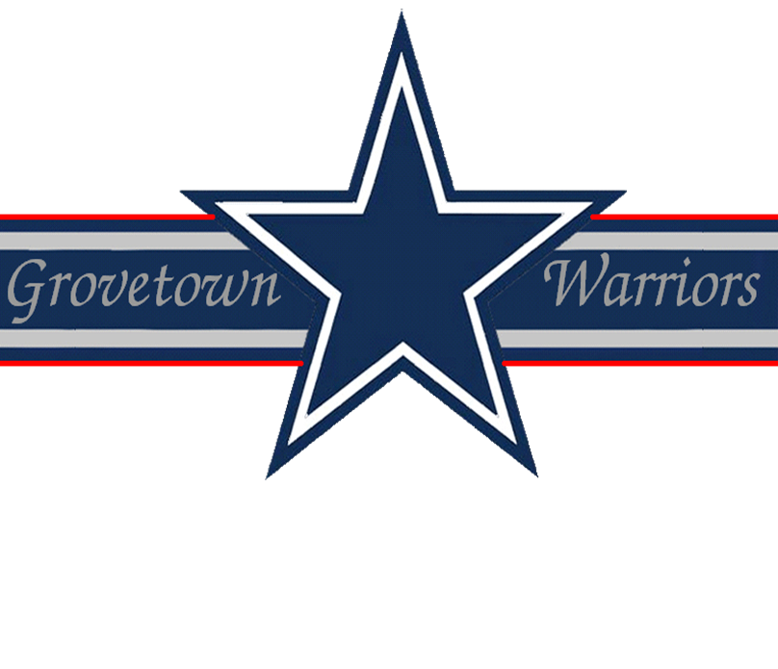

Drill & Ceremonies
1. At what angle is the head turned when the command EYES RIGHT is given at the halt?
45 degrees.
2. If you are drilling troops, should you be at the position of attention or parade rest?
Attention.
3. On what foot would you give the command halt?
As either foot strikes the ground.
4. What command is given to revoke a preparatory command that was given?
AS YOU WERE.
5. What direction do you turn in rear march?
To the right.
6. At what command do you assume the position of attention?
FALL IN or ATTENTION.
7. How would you dismiss a formation of unarmed troops?
Give the command DISMISSED.
8. What commands are given to align the squad in column?
COVER, and RECOVER.
9. What are the two elements of a two-part command?
The preparatory command and the command of execution.
10. How many steps are in quick time and how long are the steps?
120 steps per minute with a 30-inch step.
First Aid
1. What is the definition of first aid?
First aid is the emergency care given to the sick, injured or wounded before medical treatment can be administered by medical personnel.
2. Who carries the first aid pack in combat?
Every soldier.
3. What is the best way to give artificial respiration?
Mouth to mouth artificial respiration.
4. When administering mouth to mouth or mouth to nose, how many times per minute should you repeat the cycle?
12 times per minute.
5. What are the three methods that can be used to clear an obstruction from the throat of a conscious victim?
- Back blows
- Abdominal thrusts
- Chest thrusts
6. What kind of artificial respiration is used in contaminated areas?
Chest pressure arm lift method.
7. What is a fracture?
A broken bone.
8. What are the two types of fractures?
- Compound or open fracture (bone through the skin)
- Simple or closed fracture
9. What equipment can be used as a splint?
Rifles, boards, tree limbs, or anything flat.
10. When should a patient not be placed in the shock position?
When the patient has a head injury.
Flags, Guidons, Streamers, Automobile and Aircraft Plates
1. What is known as the hoist of the flag?
The length of a flag.
2. What is known as the fly of the flag?
The width.
3. What is known as the halyard?
The rope.
4. What is known as the truk (pronounced truck)?
The ball at the top of the mast.
5. What is known as the mast?
The flagpole.
Leadership Counseling
1. What are the three approaches to counseling?
Directive, nondirective, and combined.
2. Is performance counseling limited to bad performance?
No, counseling should be for good performance as well.
3. Is it an absolute requirement that leaders regularly counsel their soldiers?
Yes. The leader who neglects to counsel his subordinates is negligent in his performance of duty.
4. What DA Form is used for counseling?
DA Form 4856-R, General counseling form.
5. What is Active Listening?
Active listening involves concentrating on what the soldier is saying and letting him know that he is being heard and understood.
Map Reading
1. Why are colors used on a map?
To facilitate the identification of features on a map, the topographical and cultural information.
2. What are three norths on a military map?
- Magnetic
- True
- Grid
3. Are the legend symbols always the same on every map?
No.
4. How can you identify the map you want to use?
By sheet name and numbers.
5. What are the two methods used for finding an azimuth using a compass?
- Centerhold method
- Compass to cheek
Military Courtesy
1. What is considered the most important of all courtesies?
The Salute.
2. When in formation or on detail, who salutes?
The person in charge.
3. Do you normally salute indoors?
No, you do not normally salute indoors
4. The Secretary of Defense receives how many gun salute?
The Secretary of Defense receives a 19 gun salute.
5. Do enlisted personnel exchange salutes?
It is not customary for enlisted personnel to exchange salutes, except in some ceremonial situations.
Military History
1. Who was the first General to lead an American Army?
General George Washington.
2. Who wrote the first field manual on Drill and Ceremonies?
Major General Baron Von Steuben.
3. What was General Douglas MacArthur’s rank when he retired?
General of the Army.
4. What service is the oldest (Army, Navy or Air Force)?
US Army: established 14 June 1775.
5. When was the Constitution of the United States written?
1787.
Military Leadership
1. What is the most fundamental and important organizational technique used by the Army?
The chain of command.
2. How does a leader provide direction?
- Knowing and maintaining standards
- Setting goals
- Planning
- Making decisions and solving problems
- Supervising and evaluating
3. Define the word "proficiency" as it applies to military leadership?
The technical, tactical, and physical ability of the individual and the unit.
4. What are beliefs?
Beliefs are assumptions or convictions that an individual knows to be true regarding people, concepts or things.
5. What four emotions must you, as a leader, inspire in yourself and your soldiers that will combat fear, panic and stress?
Confidence, purpose, meaning, and self-respect.
6. What is communication?
It is the exchange or flow of information and ideas from one person to another.
Physical Fitness
1. What are the four FITT factors?
- Frequency
- Intensity
- Time
- Type
2. May the scorer stand while scoring the push-up event?
No, the scorer must kneel or sit about three feet from the tester’s hip.
3. What alternate aerobic events are there for the APFT?
- 800 yard swim test
- 6.2 mile stationary bicycle ergometer test
- 6.2 mile bicycle test
- 2.5 mile walk test

