JROTC
CAPTAIN
EXAM STUDY GUIDE
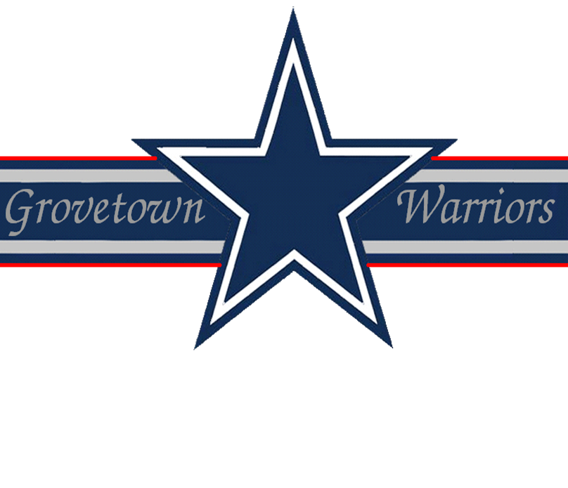

Drill & Ceremonies
1. What are the rest positions from the halt?
- Parade rest - it may be given from the command of attention only
- Stand at ease - it may be given from the command of attention or parade rest
- At ease - it may be given from the command of attention, parade rest stand at ease, or rest
- Rest - it may be given from the command of attention, parade rest, stand at ease, or at ease
2. What is the difference between interval and distance?
- Distance is the space between elements when the elements are one behind the other
- Interval is the lateral space between soldiers or elements in a formation, measures from left to right
3. On what side of a formation is a guide always positioned in a column formation?
On the right side front corner of formation.
4. What are the seven parts of review?
- Formation of the troops
- Presentation and honors
- Inspection
- Honors to the nation
- Remarks
- March in review
- Conclusion
5. How do you close ranks?
On the command close ranks, march, the first rank takes four 15 inch steps to the rear, the second rank takes two 15 inch steps to the rear, the third rank remains in place, and the fourth rank takes one 30 inch step forward.
6. What are the two pieces of music played at a retreat ceremony and in what order are they played?
"Retreat" and "To the Colors".
7. The platoon leader commands a column formation, FILE FROM THE RIGHT, what are the supplementary commands for the squad leaders?
Fourth squad leader commands FORWARD while the other squad leaders give the command STAND FAST.
8. What is meant by the term "post"?
Post refers to the correct place for an officer or noncommissioned officer to stand in a prescribed formation.
9. How would you dismiss a company formation of armed troops?
Give the commands:
- INSPECTION, ARMS
- READY, PORT, ARMS
- SLING, ARMS
- ORDER, ARMS
- DISMISSED
10. What are the three commands to change interval while in line?
- CLOSE INTERVAL, MARCH
- NORMAL INTERVAL, MARCH
- DOUBLE INTERVAL, MARCH
First Aid
1. What are the four life-saving measures in order?
1. Open the airway and restore breathing and heartbeat
2. Stop the bleeding
3. Protect/treat the wound
4. Treat for shock
2. What is the most effective method of preventing disease?
Cleanliness.
3. When administering mouth to mouth or mouth to nose, how many times per minute should you repeat the cycle?
12 times per minute.
4. How is an open fracture treated prior to splinting?
Stop the bleeding, then apply a dressing and bandage.
5. How should a patient with a fractured spine be transported?
Soldier should be transported on a litter or a straight board maintaining the natural arch in the back.
6. There are seven symptoms of mild nerve agent poisoning, name them.
- An unexplained runny nose
- Unexplained sudden headache
- Sudden drooling
- Difficulty seeing
- Tightness in chest or difficulty breathing
- Localized sweating or twitching
- Stomach cramp
- Nausea
7. How do you identify a person that is in shock?
A person in shock may tremble and appear nervous, may be thirsty, may become very pale, wet with sweat, and may pass out.
8. When don’t you elevate the injured part of the body above the heart to lessen bleeding?
When there is a broken bone in the injured part.
9. Name the four methods used to stop bleeding.
- Pressure dressing (the preferred method)
- Field dressing
- Manual pressure
- As a last resort, tourniquet
10. What are the four types of burns?
- Thermal burns
- Electrical burns
- Chemical burns
- Laser burns
11. What are the symptoms of heat stroke?
Clammy skin, does not perspire, hot and dry skin, extreme high temperature, unconsciousness nearly always results.
12. What are the symptoms and treatment for heat exhaustion?
Symptoms:
- Loss of appetite
- Headache
- Excessive sweating
- Weakness or faintness
- Dizziness
- Skin is pale, cool, moist and clammy
13. How do you treat superficial frostbite?
Warm at body temperature, hands on cheeks (don’t rub), fingers under armpits, and feet on buddy’s belly under clothing.
14. What is rabies?
Rabies is a disease of warm-blooded animals transmitted to humans by bites and scratches.
15. What should you do if you are bitten by a stray, domestic or wild animal?
Try to impound the animal but not kill it, unless it is a last resort. If the animal has to be killed, it should be done without injuring the head.
Flags, Guidons, Streamers, Automobile and Aircraft Plates
1. What is known as the truk (pronounced truck)?
The ball at the top of the mast.
2. How is the United States Flag displayed in a rostrum or stage?
It will be placed above and behind the speakers stand.
3. What three places is the American Flag flown at half-mast at all times?
- Arlington National Cemetery
- Tomb of the Unknown Soldier
- USS Arizona Battleship at Pearl harbor
4. In a parade, where is the unit guidon carried?
One step to the rear and two steps to the left of the company commander.
5. What is the difference between a Flag, Colors, and a Standard?
- The Flag is the emblem of our country and displayed on flag poles at Post and other Headquarters authorized to display them
- The Colors is the flag when carried in formation by dismounted troops
- The Standard is the flag when carried in formation by mounted or mechanized troops
6. Who is authorized a Distinguished Flag, Boat Flag, and Automobile Flag?
- Flag officers in the rank of Brigadier General and above
- Civilian officials of cabinet rank (e.g., Secretary of Defense)
7. When and by whom was the US Army Flag approved?
12 June 1956, by Executive Order 10670. It is the senior flag of the US Army.
8. What are the four colors of the Army Flag?
Scarlet, Blue, White, & Yellow.
9. Where are the streamers attached in a guidon?
Below the spearhead of the flagstaff.
10. How many personnel are required by a detachment or separate platoons in order to have a guidon?
20 or more military personnel.
Leadership Counseling
1. What is meant by the combined approach?
In the combined approach to counseling, the leader uses parts of directive and nondirective approaches.
2. What are the four learning steps an individual must take to further develop his counseling skills?
- The leader as counselor
- Approaches to counseling
- Counseling skills and procedures
- The art of communicating
3. What are some nonverbal signs that a soldier may be in need of counseling?
- A good performer consistently begins to perform below par
- A normally attentive person suddenly displays a lack of attentiveness of concentration
- A soldier performs deliberate acts of misconduct or refuses to follow instructions or orders
- A normally outgoing soldier becomes withdrawn and a loner
- The soldier’s general appearance is not in compliance with standards
4. What should you do with information concerning a criminal act obtained during a counseling session in confidence?
A leader who gains information concerning a criminal act during counseling has a responsibility to report it to the proper authorities. The counselee has a right to be informed of this limitation on confidentiality before session reveals possible criminal activity.
5. What are the leader follow-up measures?
- Let the chain of command know the results of the counseling
- Take action or make referrals agreed upon during the counseling
- Continue to evaluate the situation
- Recognize positive results
- Take corrective measures for poor results
Map Reading
1. What does the color yellow represent on an overlay?
A contaminated area.
2. Why are colors used on a map?
To facilitate the identification of features on a map, the topographical and cultural information.
3. What is a representation fraction?
A numerical scale. Indicates the relationship map to ground distance.
4. What is the declination diagram?
The declination diagram is the angular difference of magnetic north and grid from true north.
5. What is dead reckoning?
A technique of following a set route or line for a determined distance.
6. What is the legend of a map?
Illustrates and identifies the topographic symbols used to depict the more prominent features of the map.
7. What is modified resection?
The method of locating one’s position on the map when the person is located on a linear feature on the ground, such as a road or canal.
8. What are the three field expedient methods of determining direction?
- Shadow tip method
- Watch method
- Star method
9. What are the 5 major and 5 minor terrain features found on a military map?
- Major: hill; saddle; valley; ridge; depression
- Minor: Draw; spur; cliff; cut; fill
10. What is a NEAT line?
It is the outer line of a map that you align other maps with.
Military Courtesy
1. How does a soldier report to the Commanding Officer or President of the Board?
- Remove headgear
- Knock
- Enter when told to do so
- Halt two paces in front of the person to whom report
- Salute (the salute is held as long as you are reporting or until the salute is returned)
- Address the president, state your rank and full name, and report (Example: Sergeant Major, Sergeant Smith reports)
2. What holiday is the National Flag displayed at half staff from reveille until noon?
Memorial Day: at 1200 hours the national salute (21 guns) will be fired and the flag hoisted to the top of the staff and will so remain until retreat.
3. If you are in a room and an officer enters the room, what actions should you take?
If an officer enters the room while I am in the room, I would come to attention and give the greeting of the day.
4. How does the hand salute differ when you are reporting or rendering courtesy and when in formation?
When reporting or rendering courtesy, the head and eyes are turned to the person addressed. When in formation, your head and eyes are directly to the front.
5. Do you render a hand salute while double timing?
While double timing, you do not render a hand salute. You must come to a quick time before rendering a hand salute.
6. What are the terms of respect when speaking to male and female officers and civilian officials?
When addressing male and female officers and civilian officials, the terms sir and ma’am will be used.
7. What is meant by under arms?
Under arms refers to the carrying of arms or having them attached to the person by slings or holsters.
8. How is the salute rendered by sentries posted with a rifle?
The salute is rendered from the HALT and when armed with a rifle, PRESENT ARMS is rendered.
9. Who wrote the "Star Spangled Banner"?
The "Star Spangled Banner" was written by an American POW, Francis Scott Key, of Baltimore, Maryland on 14 September 1814 during the British bombardment of Fort McHenry.
10. Are salutes required to be rendered by or to personnel who are driving or ridding in privately owned vehicles?
No.
Military History
1. Who demanded, "Send me men who can shoot and salute"?
General Pershing, First World War.
2. Who was the leader of the famous Third Army during WWII?
General George Patton.
3. Name three officers who held the rank of General of the Army.
- Douglas MacArthur
- Dwight D. Eisenhower
- Omar Bradley
- George C. Marshall
4. The first field manual was entitled, "The Regulations for the Order and Discipline to the Troops of the United States", and commonly known as the Blue Book. When and why was it written?
Written in 1779 to ensure continuity and uniformity of discipline in the US Army.
5. Who was a member of the 35th Division in WWI and later became president?
Harry S. Truman.
6. Who was the first person to be assigned a serial number?
General Pershing.
7. When was the Constitution of the United States written?
1787.
8. How much of the Senate is elected every two (2) years?
One-third.
9. How many members are in the House of Representatives?
The House of Representatives has 435 members. The number representing each state is determined by population, but every state is entitled to at least one.
10. The resident Commissioner from Puerto Rico is elected to serve how many years?
Four. He takes part in discussions but has no vote.
Military Leadership
1. Explain what a leader must be, know and do.
A leader must be:
- A person of strong and honorable character
- Committed to the professional army ethic
- An example of individual values
- Able to resolve complex ethical dilemmas
A leader must know:
- The four factors of leadership and how they affect each other
- Standards
- Him/Herself
- Human nature
- His/Her job
- His/Her unit
A leader must do:
- Provide direction
- Provide purpose
- Provide motivation
2. What is justice?
It is the fair treatment of all people regardless of race, religion, color, sex, age, or national origin.
3. What are some of the pressures to be unethical?
- Pressure from self-interest
- Pressure from peers
- Pressure from subordinates
- Pressure from a senior
4. What must you do and have in order to influence the beliefs and values of your soldiers?
You must respect your soldiers and have their respect.
5. What are the nine leadership competencies?
- Communications
- Supervision
- Teaching and counseling
- Soldier team development
- Technical and tactical proficiency
- Decision making
- Planning
- Use of available systems
- Professional ethics
Physical Fitness
1. Why are ability group runs more effective than a unit formation run?
An ability group run allows soldiers to train in groups of soldiers with near ability. Each group runs with the intensity to produce a training effect for that group.
2. May the scorer stand while scoring the push-up event?
No, the scorer must kneel or sit about three feet from the tester’s hip.
3. Is it legal to pace a soldier during the 2-mile run on the APFT?
Yes, as long as there is no contact.
4. What is the recommended sequence of warm-up activities for a physical fitness session?
- Slow jogging in place or walking 1-2 minutes
- Slow joint rotation exercises 5-10 seconds for each major joint
- Slow static stretching of the muscles to be used 10-15 seconds for each stretch
- Calisthenics exercises enough to increase intensity level
- Slowly mimic activities to be performed
5. What considerations are taken for the cool-down period?
- Gradually bring the body back to the resting state
- Repeat stretches done during the warm-up, holding the stretch for 30 seconds or more
- Be careful not to over-stretch

