GROVETOWN HIGH SCHOOL
WARRIOR BATTALION JROTC
CADET HANDBOOK 2014-2015
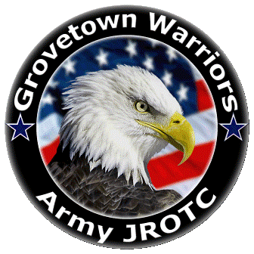

“LEAD TO TRAIN, TRAIN TO LEAD”
2010 WARRIOR WAY
GROVETOWN GA 30813
(706) 447-2102

A MESSAGE FROM GROVETOWN HIGH SCHOOL’S SENIOR ARMY INSTRUCTOR

MAJ Rodney Tyson U.S. Army (RET)

It is with a genuine concern and a sincere sense of pride for each of our students that Grovetown High School and the Army Junior Reserve Officers' Training Corps (JROTC) Department welcomes you to the JROTC program. We anticipate an exciting year of learning, growing, and working together as a team. I challenge each cadet in the Warrior Battalion to put your very best into the program and it will help mold you for the challenges of the future!

While it appears necessary to underscore that a high school student does not incur an obligation for future military service by virtue of enrolling in JROTC, it is equally essential to highlight some of the many advantages that accrue to a young person who enrolls in this course of instruction.

The JROTC Program, like academic courses in English, History, Science, & Mathematics, offers credit toward a high school diploma. JROTC cadets receive instruction in a variety of valuable subjects not available in other aspects of the school curriculum--subjects that have application in all walks of life. Our cadets will have the challenge and accompanying satisfaction of assuming leadership responsibility early in their formative years. Our cadets will learn basic leadership principles the first year then take the responsibility of leadership and teach those principles and techniques during succeeding years. Cadets will plan and direct unit training, make decisions on matters pertaining to personnel and discipline, and assume command responsibilities. Young people training in the business sector must wait years to gain many of these experiences and to exercise this type of authority.

If you are now or later consider a military career, you will find that participation in JROTC gives you an advantage in applying for a college ROTC scholarship or for admittance to one of the United States Military Academies. Additionally, a young person who has applied himself well in JROTC and who may choose to enter one of the military services, to include the National Guard, may enter at one to two grades and pay scales higher than one who has not participated in JROTC. More importantly, no matter what your career aspirations, you will gain a broader perspective of life by having taken this course!

INDEX

- PURPOSE OF AJROTC
- HISTORY OF AJROTC
- WARRIOR BATTALION & UNIT PATCH
- INTRODUCTION
- GENERAL INFORMATION
5.1 Mission of JROTC
5.2 Benefits of the JROTC Program
5.3 Enrollment
5.4 Dismissal from the Corps of Cadets
- LEADERSHIP EDUCATION TRAINING (LET) COURSES
6.1 General
6.2 Course of Study
6.3 Curriculum
6.4 Use of Cadets as Instructors
6.5 Grading System
6.6 Classroom Procedures
- UNIFORMS
7.1 General
7.2 Responsibilities and Maintenance
7.3 Correct Uniform
7.4 Physical Training Uniform
7.5 ACUs
7.6 Uniform Restrictions & Requirements
- THE CADET CORPS
8.1 General
8.2 Communication Channel
8.3 Cadet Duty Positions Descriptions
8.4 Cadet Regulations
8.5 Promotion Criteria
8.6 Normal Schedule for JROTC
8.7 Special Teams
IX. AJROTC AWARDS & DECORATIONS
9.1 General Information and Reasons for Awards
9.2 How to Earn Ribbons and Awards
9.3 Academic Awards (N-1 Ribbons)
9.4 Athletic Awards (N-2 Ribbons)
9.5 Military Awards (N-3 Ribbons)
9.6 Miscellaneous Awards (N-4 Ribbons)
X. GENERAL KNOWLEDGE
10.1 Cadet Rank
10.2 Cadet Creed
10.3 Preamble of the Constitution
10.4 Chain of Command
10.5 JROTC Courtesy
10.6 How to Properly Fold Flag
10.7 Cadet Boards
10.8 Weekly Inspection Assessment Reports

Purpose of AJROTC

In accordance of Title 10, Section 2031 subsection (A2) The purpose of Junior Reserve Officers’ Training Corps to instill in students in United States secondary educational institutions the values of citizenship, service to the United States, and personal responsibility and a sense of accomplishment. Not only maintaining Title 10, Section 2031 subsection (A2) we as the War Eagle Battalion will also instill a sense of pride into each and every cadet while building self-esteem, teamwork, and self-discipline.

Mission Statement:

“To motivate young people to be better citizens”

Results:

- We prepare high school students for responsible leadership
roles while making them aware of their rights, responsibilities,
and privileges as American citizens.

- Our program is a stimulus for promoting graduation from
high school by empowering young people to prepare for their
future.

- We provide instruction and rewarding opportunities that will
benefit the student, community, and nation.

- “JROTC is an elective and students do not incur any military
obligation by taking JROTC.”

History of AJROTC
The United States Army Junior Reserve Officers' Training Corps (JROTC) came into being with the passage of the National Defense Act of 1916. Under the provisions of the Act, high schools were authorized the loan of federal military equipment and the assignment of active duty military personnel as instructors. In 1964, the Vitalization Act opened JROTC up to the other services and replaced most of the active duty instructors with retirees who worked for and were cost shared by the schools.
Title 10 of the U.S. Code declares "the purpose of Junior Reserve Officers' Training Corps is to instill in students in United States’ secondary educational institutions the value of citizenship, service to the United States, personal responsibility, and a sense of accomplishment."
The JROTC Program has changed greatly over the years. Once looked upon primarily as a source of enlisted recruits and officer candidates, it became a citizenship program devoted to the moral, physical, and educational uplift of American youth. Although the program retained its military structure and the resultant ability to infuse in its student cadets a sense of discipline and order, it shed most of its early military content.
The study of ethics, citizenship, communication, leadership, life skills and other subjects designed to prepare young men and woman to take their place in adult society, evolved as the core of the program. More recently, an improved student centered curriculum focusing on character building and civic responsibility is being presented in every JROTC classroom.
JROTC is a continuing success story. From a modest beginning of 6 units in 1916, JROTC has expanded to 1645 schools today and to every state in the nation and American schools overseas. Cadet enrollment has grown to 281,000 cadets with 4,000 professional instructors in the classrooms. Comprised solely of active duty Army retirees, the JROTC instructors serve as mentors developing the outstanding young citizens of our country.

Warrior Battalion

Army JROTC Cadets at the Grovetown High School are organized into a battalion. In the War Eagle Battalion, a Cadet Lieutenant Colonel commands the battalion, also known as the Battalion Commander. This Cadet is responsible for making operational decisions for the Cadet Battalion. A Command Sergeant Major, an Executive Officer, a staff, Battalion Officers, and Battalion Noncommissioned Officers not only assist the Battalion Commander, but works as a functioning team to ensure battalion achievements.

The War Eagle Battalion is pleased to be a part of the Cadet Command’s Sixth Brigade, which contains 451 JROTC programs. The Cadet Command’s Sixth Brigade is responsible for JROTC programs located in Louisiana, Mississippi, Alabama, Georgia, Florida, Puerto Rico, and the Virgin Islands. The Headquarters of the Cadet Command’s Sixth Brigade is located at Hunter Army Airfield Georgia.

Introduction

As a JROTC Cadet you are embarking on one of the most interesting and valuable educational experiences of your high school career. In JROTC you will be given the chance to participate in your education and will learn to be a better citizen. The program provides you with tools and skills you can use to succeed in high school, but far more important, these tools and skills will be useful for the remainder of your life.
You will learn to:

- Appreciate the ethical values that underlie good citizenship.
Citizenship, taught through a study of history and government, demonstrates the importance of commitment and strengthens your character and resolve as you grow. You will learn to make ethical decisions based on core values.

- Develop leadership potential and learn to live and work cooperatively with others.
Teamwork and leadership, within teams and groups, are essential to the smooth operation of any organization. You will develop leadership skills so you can work in a team. Community service, drills, challenges, and other competitions make learning teamwork and leadership challenging fun.

- Think logically and communicate effectively both orally and through writing.
You will learn important skills in writing, reading, and test taking that will allow you to excel in your classes outside of JROTC. You will learn basic problem solving, financial planning, and conflict resolution; life skills that will help you live in the modern world.

- Appreciate the importance of physical fitness in maintaining good health.
Fitness, wellness, and good nutrition are necessary to perform as a citizen and a leader. JROTC will teach you what needs to be done to become fit and to maintain that fitness. Instruction will be provided on how your brain functions, how you can maximize your learning and effectiveness, and how to avoid pitfalls such as substance abuses.

- Understand ways to resist negative peer pressure and support others.
It is one thing to know how to make better choices for yourself, and another to teach others to do the same. Through service learning you will be able to help others to develop the positive strategies you have learned that will enhance their quality of life.

- Develop mental management abilities.
You will be able to assess your skills and learn to make more logical, positive decisions and choices. You will learn how to set goals and develop an action plan that will help you to achieve those goals. As you become a better citizen, a better leader, and a better team member your self-esteem will increase. Your “Can Do” attitude will show beyond JROTC.

- Become familiar with military history as it relates to America’s culture.
Learn not only about important events in our history, but also about their effect on our society. Discover the role the military services play in supporting the nation.

- Understand the importance of high school graduation to a successful future. Develop the means and motivation to graduate from high school and to pursue a meaningful life.

- Learn about college and other advanced educational and employment opportunities.
You will learn about the many varied opportunities that are available to you upon graduation. The foundation and competency skills required to work effectively are ingrained throughout the curriculum.

SECTION V
General Information

  - Mission of JROTC
- The Mission of JROTC is to “Motivate young people to be better citizens.”

5.2 Benefits of the JROTC Program
- NO MILITARY OBLIGATIONS. Participation in the JROTC program does
not in any way cause the student to incur a military obligation.

- CREDIT TO GRADUATE. One credit toward graduation for each semester
of JROTC is successfully completed.

- SOCIAL ACTIVITIES. Each cadet has the opportunity to participate in social
activities conducted by the Corps of Cadets. This will include the annual
Military Ball, and a Cadet Social conducted at the beginning of the year.

5.3 Enrollment
- To be eligible for enrollment and continuance as a member of the Corps of
Cadets, you must:

1. Be enrolled in and attending full-time, a regular course of instruction at
Grovetown High School
- Be a citizen of the United States or be a legal resident.
- Have completed eighth grade.
- Maintain an acceptable standard of academic achievement, which warrant
normal progression and will merit graduation upon completion of the school
academic requirements.

- Qualified students will normally be enrolled in the following Leadership
Education and Training (LET) courses:

1. First year: JROTC Army Leadership Education 1 (LET 1) (RTC 201-202)
2. Second year: JROTC Army Leadership Education 2 (LET 2) (RTC 203-204)
3. Third year: JROTC Army Leadership Education 3 (LET 3) (RTC 205-206)
4. Fourth year: JROTC Army Leadership Education 4 (LET 4) (RTC 207-208)

5.4 Dismissal from the Corps of Cadets
Some infractions require immediate dismissal and do not qualify for review (i.e. failure to wear the uniform, expelled from school, deliberately seriously injuring another Cadet). Otherwise, Cadets may be dismissed from the Corps for serious infractions or reasons as described below.

In all cases, the decision rendered by the SAI is FINAL in that he is the final appeal authority as required by Cadet Command Regulation 145-2, which governs the operation of the JROTC program.

In all cases, the following action committed by a Cadet may result in their Dismissal from the Junior Reserve Officers’ Training Corps of Cadets:

  - Failure to maintain acceptable standards of academic achievement, conduct or
attendance.

  - Exhibition of undesirable traits of character as demonstrated by cheating on
quizzes, tests, or exams, stealing, unauthorized possession of illegal drugs,
lying, conviction or adjudication as a juvenile offender for commission of a
felonious act, frequent acts of a discreditable nature with civil or school
authorities, or violation of school policy.

  - Show of indifference to leadership training as demonstrated by frequent
absences from class, established patterns of shirking, insubordination in
JROTC or other classes, and failure to wear the uniform on established dates.

SECTION VI
Leadership Education Training (LET) Courses

6.1 General
- Training will be conducted in accordance with the U.S. Army Cadet Command Program of Instruction (POI) and school policies. The JROTC course imposes NO military obligation on any Cadet.

- The desired learning outcomes of the JROTC program are to develop the
following in each Cadet:

    - Appreciation of the ethical values and principles that underlie good citizenship. These include integrity, responsibility, patriotism, and respect for constituted authority.
    - Leadership potential and the ability to live and work cooperatively with others.
    - Ability to think logically and to communicate effectively (both verbally and in writing).
    - Appreciation of physical fitness in maintaining good health.
    - Familiarity with the history, purpose, and structure of the military and an appreciation of the U.S. military in support of national objectives and strategies.
    - Knowledge of civilian and military educational and vocational opportunities.

6.2 Course of Study
  - The JROTC program of study at Grovetown High School is a four-year/eight semester elective course. There are four periods of instruction per week with a mix of classroom and practical exercise activities.

  - Throughout the course of instruction the JROTC textbooks will be the primary reference material. These textbooks contain all the material and data a student needs to adequately study and prepare for classroom assignments, quizzes, essays, and tests. Certain projects and assignments will require the use of a library as well as the Internet or other outside resources.

  - Use the GTHS JROTC website (www.gthsjrotcbatalion.weebly.com) for a reference if needed.

6.3 Curriculum
- RTC 201-202 Prerequisite: None Credit: 1
JROTC Army Leadership Education 1 Grade Level 9-12 Status: Elective
The basic course includes a study of the Spirit of American Citizenship and Army JROTC, Techniques of Communication, Leadership, Drill and Ceremonies, Introduction to Cadet Challenge, First Aid, Map Reading, Overview of Citizenship through American History, Your American Citizenship, and Marksmanship. (Teaching material provided by Army)

- RTC 203-204 Prerequisite: RTC 201-202 Credit: 1
JROTC Army Leadership Education 2 Grade Level 10-11 Status: Elective
The second year of JROTC continues the instruction begun in the first year. It includes Techniques of Communication with a concentration on writing skills, Training for Cadet Challenge, Drill and Ceremonies, First Aid and Hygiene, an Introduction to Drug Abuse Awareness, Training in Map Reading, American Military History, Your American Citizenship, Role of the U.S. Army in National Affairs, Technology Awareness, and Marksmanship.
(Teaching material provided by Army)

- RTC 205-206 Prerequisite: RTC 203-204 Credit: 1
JROTC Army Leadership Education 3 Grade Level 11-12 Status: Elective
The third year of Leadership Education and Training includes a continuation of Training in Techniques of Communication; Leadership Training with an Emphasis on Problem Solving Techniques; Training for Cadet Challenge; First Aid, Drill and Ceremonies; Drug Abuse Prevention Training; Map Reading; American Military History; Federal Judicial System; Role of the Armed Forces; Technology Awareness; Career Opportunities; and Cadet Challenge.
(Teaching material provided by Army)

- RTC 207-208 Prerequisite: RTC 205-206 Credit:1
JROTC Army Leadership Education 4 Grade Level: 12 Status: Elective
The fourth year of training is based on a curriculum focused on having the student demonstrate the ability to work self-paced and to complete work in a given time frame. Subjects covered are Techniques of Communication, Leadership, Preparation for Cadet Challenge, Drug Abuse Prevention Programs, and Drill and Ceremonies, American Military History from the Revolutionary Period to the Civil War, American Citizenship as it applies to Individual Responsibilities, Command and Staff procedures at the Battalion Level, Cadet Challenge, and Marksmanship.
(Teaching material provided by Army)

6.4 Use of Cadets as Instructors
- Selected Cadets will be utilized as Assistant Instructors, for the entirety of the year, in teaching first and second year Cadets. Cadets selected for this role will receive detailed instruction and rehearsal requirements from the SAI or AI.

- To further develop a Cadet’s leadership skills as an effective communicator, he/she will participate in the training of the Corps during drill and ceremony classes and team instruction.

6.5 Grading System
- The grading system used in the JROTC Department is designed to take into account the broad diversity of essentials in which each Cadet is takes place in. Performance exercises, essays, quizzes, examinations, homework, and individual and group projects measure the level of student performance.

- Elements of the grading scale will also include the following:

1. Proper wear of the uniform. Any Cadet who does not wear the uniform
COULD POSSIBLY FAIL JROTC.
      - Attendance in class
      - Demonstrated leadership in all classes and respect for others
      - Display of ethical values
      - Response to student leaders and respect for their appointed authority
      - Participation in Physical Training (PT) and other mandatory JROTC events.

6.6 Classroom Procedures
- The appointed class leaders (Commanders and Facilitators) are responsible for
Forming the class, taking role, and reporting the class prepared for instruction to the SAI or AI. They are also responsible for forming the class during drill and ceremony, and assisting in other duties as assigned.

- As soon as the bell rings the class leaders will close the door and form the
unit. The unit will recite the Cadet Creed, Preamble, and Company Motto prior to sitting down.

III. When the end of class bell rings, cadets will leave class ONLY when given permission to be dismissed

SECTION VII
Uniforms
7.1 General
The uniform is a symbol of a proud and honorable profession. As a JROTC Cadet, you are expected to maintain high standards in both personal appearance and military bearing. Wearing of the uniform proudly and correctly is a large part of the image you project to all who view you while wearing it. When wearing the uniform, you must remember that you are representing the Cadet Corps, the community, Grovetown High School, and the many men and woman that are before us that wear this uniform to protect the world in the armed forces. In any case it may be, your appearance in this uniform not only reflects you as a cadet, but your high school, your JROTC program, and the Active Army that you as a cadet share uniforms with. Cadet leaders in uniform have the responsibility in correcting improper wear of the uniform by cadets as well as notifying the SAI or AI if a problem continues.

7.2 Responsibilities and Maintenance
Before any Cadet is issued a uniform, his/her parent or guardian must complete and sign “Privacy Act Statement” assuming financial responsibility for loss or damage due to neglect of all/any items issued to the Cadet. Before signing his/her clothing record, each Cadet must carefully check all issued items to ensure proper accountability. The cost of cleaning, laundry, and normal maintenance of the uniform while in the possession of the Cadet, will be the Cadet’s responsibility.

7.3 Correct Uniform
Since Junior ROTC Cadets wear the same uniform as the Active Army, the same regulations govern its wear. Each Cadet should wear his/her uniform with pride and respect to reflect credit upon him/herself and the Cadet corps. Cadets should remember the school, and the entire Cadet corps is judged by both appearance and personal conduct while in uniform.

The following guidelines should be followed for proper wear of the uniform:

- Anytime the uniform is worn, it is to be complete. Unauthorized mixtures of civilian clothing and uniforms, or different types of uniforms WILL NOT be worn.

- Whenever the uniform is worn, it will be cleaned and neatly pressed, fully buttoned, with shoes shined, and brass polished.

- No civilian clothing will be worn with the uniform (i.e. civilian raincoats, hats, rain boots, etc.) and concurrently; no part of the uniform will be worn with civilian clothing (i.e. overcoats, field jackets, etc.). The SAI or AI may authorize exceptions.

- Any Key GTHS Leader not in proper uniform on uniform day is subject to immediate reduction in rank, corrective training, and/or relief for cause for failing to set a proper example.

- If issued, the proper headgear will be worn when a Cadet is outdoors and not under cover. Cadets will remove their headgear when indoors except when under arms. shoes must be black in color. Male Cadets will wear black socks with low quarter shoes. Female Cadets will wear natural color nylons with black pumps or black socks with low quarter shoes.

- Cadets WILL NOT walk around indoors or outdoors with their hands in their pockets.

- On uniform days, and on special occasions as directed, Cadets will wear the prescribed uniform for the entire day. Unless special arrangements are made and approved beforehand, members of selective teams will wear the JROTC uniform on uniform day. REMEMBER, an essential part of your JROTC grade is the proper wearing of the uniform on the prescribed day. If your uniform is accidentally soiled or damaged, rendering it temporarily unserviceable, bring the uniform to school PRIOR TO WEDNESDAY so the condition may be verified by the SAI or AI. Sending the uniform to the cleaners and not having it returned on time for uniform days is not a valid excuse for being out of uniform. A NOTE FROM HOME SEEKING EXCUSAL FROM FAILURE TO GET THE UNIFORM CLEANED ON TIME IS UNACCEPTABLE. The SAI or AI may grant rare exceptions to this on a case-by-case basis.

- Cadets are not to participate in any kind of sports activity that may cause damage to the uniform. Personnel attending shop classes will ensure their uniform is protected or is taken off while in shop.

- Cadets WILL NOT publicly display affection such as kissing, holding hands, or hugging while in uniform, or in civilian clothes in the JROTC designated area.

- ONLY APPLICABLE TO CLASS B, CLASS A, AND DRESS FOR SUCCESS: Any Cadet that takes off their uniform before the school day has concluded, WILL receive and automatic ZERO and will be subject to corrective training. Only exception to this rule is if the cadet is required to take off their uniform for a required class (e.g. Auto Shop, Gym, Culinary, etc.). If a cadet is part of the exceptions listed above, there must prior approval from the SAI.

7.4 Physical Training Uniform
The Physical Training (PT) uniform consists of a grey GTHS AJROTC shirt, Blue GTHS AJROTC shorts, a grey GTHS AJROTC hoodie, and grey GTHS AJROTC sweatpants. Cadets are required to wear the PT uniform every Thursday (which is PT day). Unless the SAI or AI otherwise requests it, and the PT uniform should only be worn on that day. You will have time to go to the locker room and change into PT uniform, or if you choose, you may wear it the entire day. Cadets who are not in the proper PT uniform will receive a ZERO for PT that day. If for any reason your PT uniform becomes, missing, or ruined you will need to inform your squad leader so they can either receive another PT order form for you, or inform the First Sergeant to see if extras are in inventory.

7.5 ACUs
Cadets will be issued ACUs for attending JROTC Leadership Challenge (JCLC) camps. Cadets will also be issued ACUs for functions where a Class A/B uniform is unsuitable such as Raider events, Orienteering events, Leadership Labs, and other training.

7.6 Uniform Restrictions & Requirements
I. Females:
1. Hair must be off ears, and collar.
2. Only black or natural color hair ties can be worn
3. Only black socks may be worn.
4. Nails polish must be clear or natural; nails can be a maximum ¼ of an inch long.
5. No Bracelets.
6. All necklaces must be worn underneath the shirt.

- Males:
- Neat haircut (Off the ears, and collar)
- A clean shaved face
- Side burns above ear lobe.
- Only black socks may be worn.

EX1: CLASS A: MALES
EX2: CLASS B: MALES
EX3: CLASS A: FEMALES
EX4: CLASS B: FEMALES
EX5: ACUs
EX6: DRESS FOR SUCCESS: MALES
EX7: DRESS FOR SUCCESS: FEMALES
EX8: PHYSICAL TRAINING (PT) UNIFORM
EX9: BERETS
EX10: PATROL CAPS

EX1: CLASS A (MALE)

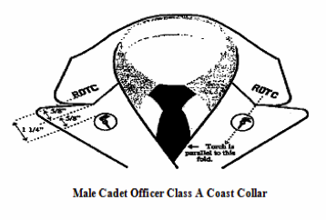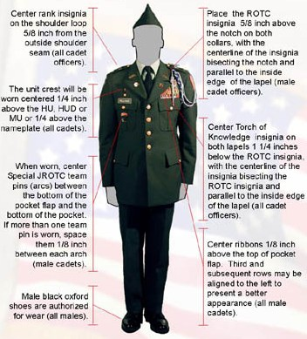

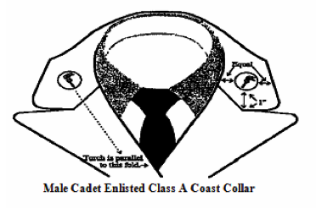

- Rank: For officers and enlisted cadets, ranks will touch the base of the shoulder tabs.
- Cords: No more than 2 chords at a time. If a cadet only has one chord, it will be used on the left side of the uniform
- Star: Centered 1/4" above the right pocket
- Nametag: Centered between the top of the pocket and the top of button
- Ribbons: Centered, 1/8" above the pocket, with no more than 3 across
- Special Team Badges: Centered on the centerfold, centered between the bottom of the left pocket flap and bottom of the pocket, if you have more than 1, 1/8" between each tab
- Earrings: Not Authorized
- Only Authorized 'Jewelry':
  - Wristwatch, ID Bracelet, 1 ring per hand
- Beards and Goatees: Not Authorized
- Arcs: Left side, Centered (top-bottom) between the bottom of the flap and the bottom of the pocket. Each pin is placed 1/4 inch apart from each other.

EX2: CLASS B (MALE)

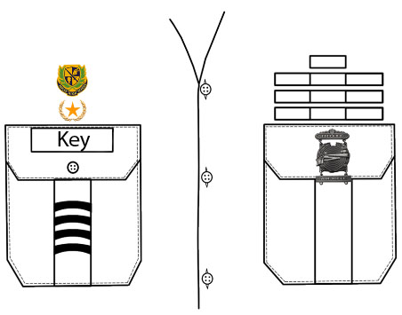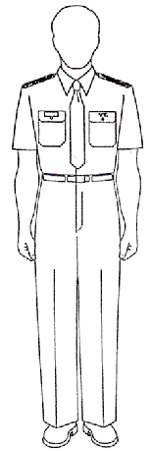
- Ranks: For officers and enlisted cadets ranks will touch the base of the shoulder tabs.
- Cords: No more than 2 chords at a time. If a cadet only has one chord, it will be used on the left side of the uniform
- Star: Centered, 1/4" above the right pocket
- Nametag: Centered with the top of the tag even with the seam
- Ribbons: Centered, 1/8" above the left pocket, no more than 3 across
- Special Team Badges: Centered between the bottom of the left pocket flap and bottom of the pocket, if more than 1, 1/8" between each tab
- Earrings: Not authorized
- Beards and Goatees: Not authorized
- Only Authorized 'Jewelry':
  - Wristwatch, ID Bracelet, 1 ring per hand.
- Arcs: Left side, centered between the bottom of the pocket flap and the bottom of the pocket. Each pin should be 1/4 inch apart from each other.

EX3: CLASS A (FEMALE)
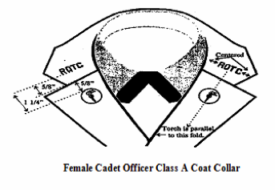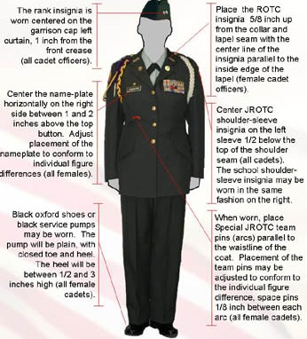

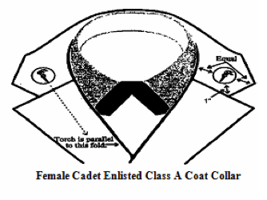

- Ranks: For officers and enlisted cadets ranks will touch the base of the shoulder tabs.
- Cords: No more than 2 chords at a time. If a cadet only has one chord, it will be used on the left side of the uniform
- Star: Centered 1/4" above the nametag
- Nametag: 1-2" above the top button
- Ribbons: Bottom of 1st row is parallel with the bottom of the nametag, with no more than 3 across
- Special Team Badges: Centered 1/4" below center badge (marksmanship), if you have more than 1, 1/8" between each tab, may be adjusted to individual figure differences
- Earrings: Matching pair with 1 earring per ear, and no greater than 1/4" in size, no loops or logos
- Other Authorized 'Jewelry':
  - Wristwatch, ID Bracelet, 1 ring per hand
- Make-up and Nail Polish: NEUTRAL, OR SKIN TONE
- Arcs: Place between the second and third button, centered (left-right) on the seam. Each Arc is placed 1/4 inch apart.

EX4: CLASS B (FEMALES)

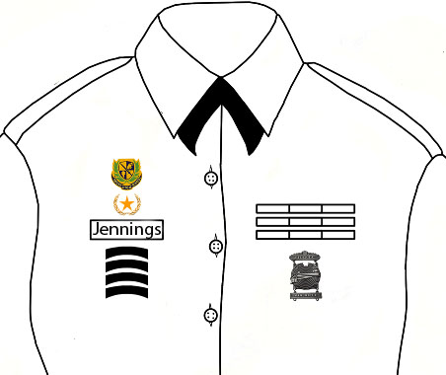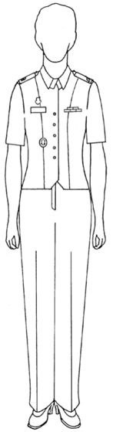
- Ranks: For officers and enlisted cadets ranks will touch the base of the shoulder tabs.
- Cords: No more than 2 chords at a time. If a cadet only has one chord, it will be used on the left side of the uniform
- Nametag: aligned with top of first button on right side, approx. 1-2" over
- Star: Centered, 1/4" above the nametag
- Ribbons: Centered, bottom of 1st row parallel with the nametag, no more than 3 across
- Special Team Badges: Centered 1/4" below the center badge (marksmanship), if more than 1, 1/8" between each tab
- Earrings: Matching pair with 1 earring per ear, and no greater than 1/4" in size, no loops or logos
- Other Authorized 'Jewelry':
    - Wristwatch, ID Bracelet, 1 ring per hand
- Make-up and Nail Polish: NEUTRAL OR SKIN TONE
- Arcs: Placed between the second and third button and centered (left-right) on the seam. Each arc is placed 1/4 inch apart from each other.

EX5: ACU (MALE/FEMALE)

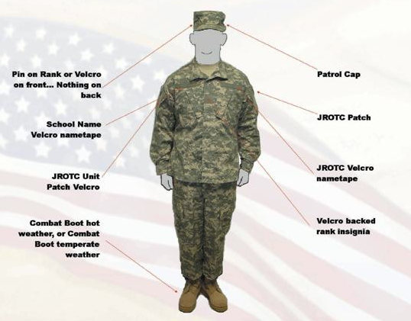
- Wearing of ACUs
- The coat has a hook and loop fasteners for wearing shoulder sleeve insignia, rank, JROTC patch, and school nametape.
- The mandarin collar will be normally worn in the down position. Cadets are authorized to wear the mandarin collar in the up position when weather conditions dictate the wear as prescribed by the SAI/AI.
- The coat is normally worn outside the trousers, and the trousers are worn with a belt. The coat may also be worn inside the trousers when directed by the SAI/AI. The coat will not extend below the top of the cargo pocket on the trousers and will not be higher than the bottom of the side pocket on the trousers.
- Sleeves will be worn down at all times, and not rolled or cuffed.
- The moisture wicking tan t-shirt or cotton t-shirt is worn underneath the coat and is tucked inside the trousers at all times.
- Cadets will wear the trousers tucked into the top of the boots or bloused using the drawstrings at the bottom of the trousers.
- When bloused, the trousers should not extend below the third eyelet from the top of the boot. The ACU is meant to fit loosely and comfortably. An alteration to hinder this is not authorized.
- Cadets will wear in accordance with CCR 145-2

EX6: DRESS FOR SUCCESS (MALE)
Acceptable Dress for Dress for Success (DFS)

I. Dress for Success (DFS) Rules
1. ALL males must wear either kakis or slacks. NO shorts or jeans!
2. ALL males must wear a collared shirt with either a tie or a bowtie.
3. ALL males must wear a belt (black or brown).
4. ALL males must wear dress shoes (YOU MAY NOT WEAR YOUR UNIFORM SHOES)!
5. ALL hoodies must be off during school hours for DFS. Exceptions to this rule
include when there is a fire drill (in which students must go outside), or if given
permission by a JROTC instructor

Unacceptable Dress for Dress for Success (DFS)

EX7: DRESS FOR SUCCESS (FEMALE)
Acceptable Dress for Dress for Success (DFS)

I. Dress for Success (DFS) Rules
1. ALL females must wear a skirt, dress, or slacks/pantsuit. NO shorts or jeans!
2. ALL females must wear a nice/professional blouse.
3. ALL dresses must be no shorter than 1 INCH above the knee, and they CANNOT
BE STRAPLESS OR HAVE SPAGETTI STRAPS.
4. ALL skirts must be no shorter than 1 INCH above the knee.
4. ALL females must wear shoes that have a 1-INCH heel (YOU MAY NOT WEAR
YOUR UNIFORM SHOES OR FLATS)
5. ALL hoodies must be off during school hours for DFS. Exceptions to this rule
include when there is a fire drill (in which students must go outside), or if given
permission by a JROTC instructor.

Unacceptable Dress for Dress for Success (DFS)

EX8: PHYSICAL TRAINING (PT) UNIFORM (MALE/FEMALE)
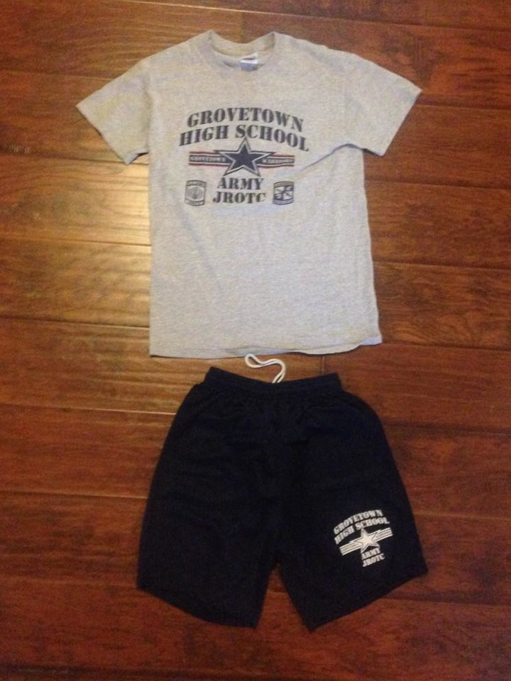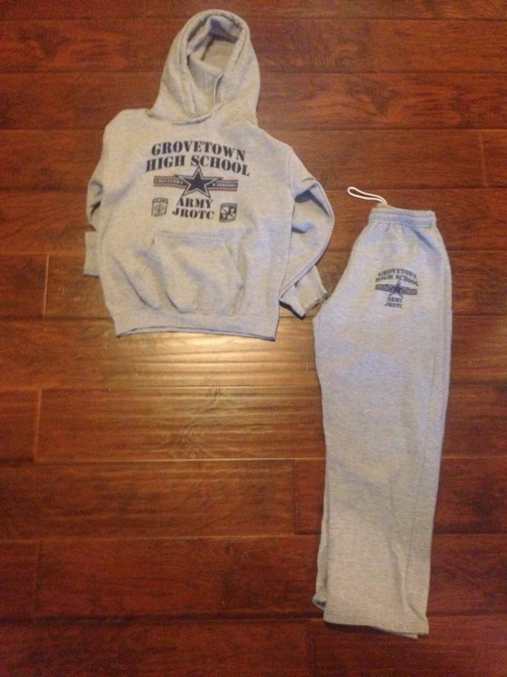

I. Physical Training (PT) Uniform Rules
1. Cadets are expected to wear their PT uniform every Thursday, unless told differently by
the SAI/AIs
2. Unless told otherwise, cadets are expected to come to formation in FULL uniform (shirt,
shorts, sweater, sweatpants, white socks, and tennis shoes)
3. The gray GTHS JROTC t-shirt must be tucked in at all times
4. If a cadet is in improper uniform they will automatically receive a ZERO for their
uniform that day.

EX9: BERETS (MALE/FEMALE)
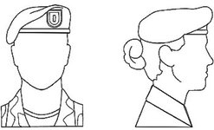

I. Wearing of the Beret
1. The beret is worn so that the headband (edge binding) is straight
across the forehead, 1 inch above the eyebrows.
2. The flash is positioned over the left eye, and the excess material is
draped over to the right ear, extending to at least the top of the ear,
and no lower than the middle of the ear.
3. When worn properly, the beret is formed to the shape of the head,
therefore, Cadets may not wear hairstyles that cause distortion of the
beret.

Officers wear their rank centered on the flash. Enlisted cadets wear their distinctive unit insignia on the flash

EX10: PATROL CAPS (MALE/FEMALE)
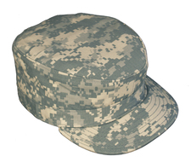

I. Wearing of the Patrol Cap
1. The ACU Patrol Cap will be the only headgear worn with the Uniform.
2. Cadets will wear the ACU Patrol Cap straight on the head so that the cap band
creates a straight line around the head, parallel to the ground.
3. The Patrol Cap will fit comfortably around the largest part of the head without
distortion or excessive gaps. The cap is worn so that no hair is visible on the
forehead beneath the cap. Sewn or pin on rank is worn on the ACU Patrol Cap
4. The Velcro area on the rear of the cap will remain blank at all times.

SECTION VIII
The Cadet Corps
8.1 General
The Corps of Cadet at Grovetown High School is very similar to that of the Army organizations, with the many leadership positions and battalion structure. The Battalion is commanded by Cadets, with certified Cadet Command Cadre as teachers, advisors, and facilitators. This gives each and every Cadet the opportunity to experience the roll of leadership in various situations with insights from a retired Soldier.

8.2 Communication Channel
- The Chain of command will be used in all matters involving orders and communication with school and Army officials concerning the JROTC program. Cadet concerns start by notifying their Squad Leader, who notifies the Company Commander, and so on. Communication will pass through the elements of the chain of command in the sequence described below (both up and down the chain):
            - SAI/AI
            - Battalion Commander
            - Company Commander
            - First Sergeant
            - Platoon Leaders or Platoon Sergeants
            - Squad Leaders
            - Cadets

8.3 Cadet Duty Positions Description
The leadership positions within the Corps structure and the ranks are listed in Section 10.1. It should never be forgotten but an honor to be able to hold a position, and the rank that accompanies it, fully knowing it was earned, and not given. Every Cadet that holds at position in the War Eagle battalion has demonstrated the capability of leading cadets through their performance (both academically and professionally) and achievements. The quantity of officers, and NCOs appointed in the Cadet Corps is determined by the total enrollment, and fluctuates each school semester. The most important thing about the Corps is that a member of the upper class does not imply automatic leadership position.

I. Battalion Commander (BC)
This position is the most demanding in a Cadet Battalion. The Instructor Staff
selects the cadet for this position based on demonstrated leadership ability and
academic standing. The appointed cadet must be able to apply common sense
and judgment in the solving of problems that affect the entire Cadet Corps.
The Battalion Commander must be mature, willing to accept responsibility, and
able to effectively delegate authority and supervise subordinates. The Battalion
Commander controls the staff through the Battalion Executive Officer and the
Companies through the Company Commanders, while maintaining the final
approval authority in the Cadet Chain of Command.
The specific duties of the Battalion Commander are to:

1. Command the Battalion at all formations.
2. Prepare and conduct the training of the Battalion on Drill days.
3. Maintain a direct and personal relationship with the Staff and the Company
Commanders.
4. Encourage the Company Commanders to communicate freely.
5. Ensure that Staff members are capable and that they understand their
responsibilities to the Battalion Commander, Battalion Executive Officer, and
to the Corps of Cadets.
6. Use the Staff to assist in gathering information and preparing plans for
conducting training and controlling the Battalion
      - Designate Staff officers to assist in the preparation, execution, and supervision of orders.
      - Ensure that feelings of mutual respect and confidence exist between the Staff
and Company Commanders.
9. Execute all responsibilities in the name of the Senior Army Instructor; seek
advice and assistance from the Instructor Staff and carry out all of their directives quickly and completely, and make sure they are in compliance with JROTC regulations, policies, directives, and with local school regulations and policies.
10. Arrange the required meetings and assemble the required command or Staff
personnel to determine any actions that may be necessary in fulfilling the
obligations of the Cadet Battalion.
11. Be prepared to evaluate any member of the Battalion, but specifically the
Battalion Headquarters personnel and the Company Commanders.
12. Make operational decisions for the Cadet Battalion.
13. Work with school authorities in coordinating activities of the Cadet Battalion
with the organizations of the school, ensuring that Battalion activities are in
accordance with school policy.
14. In coordination with the Senior Army Instructor, assign missions to all
extracurricular team captains such as Drill, Rifle, Color Guard, and so on.
15. Be responsible for all the Battalion does or fails to do.

II. Battalion Executive Officer (XO)
The Cadet Battalion Executive Officer supervises, directs, and coordinates
the Cadet Battalion Staff to prevent overlapping efforts and to ensure that the
Commander’s desires are understood and achieved. The Cadet Battalion XO
keeps the Staff informed of the Commander’s policies and keeps the Cadet
Battalion Commander informed of the status of projects assigned to the Staff.
The Cadet Battalion XO assumes command of the Cadet Battalion in the
absence of the Cadet Battalion Commander.
The primary duties of the Cadet Battalion XO are to:

1. Organize the Cadet Battalion Staff properly and ensure that it works as a
team.
2. Inspect the work of the Cadet Battalion Staff and make other inspections as
directed by the Cadet Battalion Commander.
3. Ensure that the Battalion Staff officers prepare and submit reports on time
and that they are engaged in future planning.
4. Act as the Commander of Troops during ceremonies.
- Ensure that instructions and orders issued to the Cadet Battalion are in accordance with the established policies of the Cadet Battalion Commander; report all violations of orders to the Cadet Battalion Commander.
- Perform other duties as assigned by the Cadet Battalion Commander or the
Instructor Staff.

III. Battalion Command Sergeant Major (CSM)
The Battalion Command Sergeant Major is the principal cadet enlisted assistant
to the Battalion Commander. As the senior enlisted member of the Cadet Corps,
the Command Sergeant Major supervises the other noncommissioned officers
(NCOs) of the Battalion and companies.
Specific duties of the Command Sergeant Major are to:

1. Assist subordinate NCOs, the Battalion XO, and the adjutant with administrative
duties/details.
2. Advise and assist the Battalion Commander in all matters pertaining to the
enlisted members of the Cadet Battalion.
3. Receive lists of absentees from the Companies and submit them to the adjutant.
4. Supervise the Color Guard and all flag details. Ensure that Company First
Sergeants submit their weekly flag details on time, post those rosters, and
ensure that members selected for detail receive their notification slips prior
to the assignment.
- Ensure the flag details are properly trained.
- Ensure that the Battalion area, including the Drill Field, is maintained in a
high state of police at all times and that JROTC offices and classrooms are
kept neat and orderly.
- Preside over all noncommissioned officer promotion boards.
- Assume command of the Battalion in the absence of all officers.
- Perform other duties as assigned by the Battalion Commander, Battalion Executive Officer, or the Instructor Staff
- Assist the adjutant in the formation and alignment of the Battalion at all Battalion formations.

IV. S-1: Administration
The Battalion adjutant is the administrative assistant to the Battalion Commander. The adjutant is also responsible for performing other administrative
duties as assigned by the Battalion Commander, Battalion Executive Officer, or
the Instructor Staff.
The specific duties of the Battalion adjutant are to:

- Prepares orders. directives, or announcements as directed by the Battalion Commander or Executive Officer and in conjunction/coordination with the SAI/AI.
- Prepares and maintains current organizational rosters.
- Maintains the cadet JROTC record files, correspondence and publication to include posting all necessary information JUMS cadet records.

V. S-2 Information & Security
The Battalion S-2 assists the Battalion Commander and the Instructor Staff in
matters pertaining to unit security and enforces the provisions of the security
requirements for the Battalion.
The specific duties of the S-2 are to:

- The Battalion S-2 assists the SAI/AI in matters pertaining to unit security and enforces the provisions of the security requirements for the Battalion.
- He/she reports to the Battalion Executive Officer and assists in making periodic inspections of the security of weapons.
- The S-2 makes period inspections of the security of the supply room and equipment storage areas.

VI. S-3 Operations & Training
The battalion S-3 assists the battalion commander in the preparation, conduct,
and supervision of all training activities of the cadet battalion. Additionally, the
S-3 keeps the commander advised on the progress of training within the battalion.
Specifically, the principal duties of the S-3 are to:

- The Battalion S-3 is the principal staff assistant to the commander in matters pertaining to organization, training, and primary operations. He/she also advises and assists other Staff officers in the operational aspects of their particular activities.
- The S-3 prepares all training schedules in accordance with the master training and program of instruction.
- The S-3 is responsible for the storage, maintenance, and issue of training aids and reference materials.
- The S-3 plans for, and coordinates, all of the Battalion's training activities to include field trips, parades and extra-curricular activities (JROTC, school, community support).
- Ensures that classroom and field training areas are properly prepared prior to training.
- Ensures that cadet instructors are properly prepared to give assigned classes and that the Battalion Commander is informed of the evaluation given to all Cadet Instructors.
- In absence of the Battalion Commander and Executive Officer, the S-3 assumes command of the unit.

VII. S-4 Logistics & Supply
The Battalion logistics or supply officer is responsible for the maintenance,
security, record keeping, issue, and turn-in of all U.S. government property
(except ordnance). The S-4 coordinates the securing of property with the S-2.
Some of the duties of the S-4 are to:

- Is the principal Staff assistant to the Battalion Commander in matters pertaining to the provision supply, maintenance, transportation, and miscellaneous logistic support.
- Is responsible for the storage and maintenance of accurate supply records, to include cadet clothing records, hand receipts, up-to-date inventories within the unit, and other supply actions, as directed by the SAI/AI.
- Responsible for the storage, maintenance, issue, and turn-in of all supplies and reference material as directed by the SAI/AI.
- Is thoroughly familiar with supply procedure, requisitions, turn-in salvage, laundry/dry cleaning/alterations pick-up, and inventory of equipment.
- Assigns weapons to cadets, supervises the armor in the maintenance of weapons and equipment, and maintains records of maintenance preformed on weapons.
- Responsible for the cleanliness, organization, and up-keep of the supply and arms room area.
- Responsible for the investigation of losses of issued property, under the guidance of the SAI/AI.

VIII. S-5 Public Information
The Battalion’s public information officer is the principal Staff assistant to the Commander on public information and the public relations matters between the Army and the JROTC program.
The duties of the S-5 are listed below:

- Prepares and distribute news to local media.
- Photographs major JROTC events and performances.
- Assists Staff sections during special ceremonies.
- Assists the SAI/AI in activities involving the compilation of the organizational units currently supporting the Army JROTC program. He/she will handle the preparation of invitations, the mail-outs, responses, seating arrangements, and protocol.
- Due to exposure to the public, the S-5 must be fully knowledgeable of the organizational structure and mission of the Grovetown High School Army JROTC program.
- Responsible for maintaining and creating the Battalion website with updates of current JROTC events, pictures, etc.

IX. Company Commanders
A good Company Commander is an outstanding leader with lots of initiative. Company Commanders get things done. Until orders reach a Company Commander, they are just plans, something that someone would like to have accomplished. Rather than waiting to be told what to do, Company Commanders think and plan ahead what seems best for the Company. They use common sense action and try not to worry about making mistakes, knowing that the greatest mistake is to do nothing when action is required. Company Commanders use all available
help to accomplish Company duties and to keep subordinates informed, at the same time ensuring that the goals of the mission remain in focus. A Company Commander provides the why and how to accomplish the assigned mission. They must then check and inspect to ensure that what needed to be done is being accomplished. They must be outstanding leaders with plenty of initiative. Company Commanders do not wait for someone to tell them what to do — they think ahead and plan what is best for the Company.

- Is responsible for all the Company does or fails to do.
- Keeps the Battalion Commander apprised of the status of the Company at all
times.
3. Command the Company at all formations.
4. Ensure that all members of the Company know and use the Chain of Command.
5. Consult the training schedule, study the Drill references, and ensure that you
and your subordinates are prepared to instruct.
6. Check with the Instructor Staff daily prior to formation to obtain any changes or
other information they may want announced.
7. Seek advice from the Battalion Commander or the Instructor Staff when
encountering a problem to which you do not know the answer.
8. Execute the orders of the Battalion Commander as if they were your orders,
even though you may personally disagree with them.
9. Ensures the Company is prepared to accomplish its assigned mission in a
satisfactory manner.
10.Conduct short inspections at every formation, making on-the-spot corrections
as necessary; follow-up to ensure that deficiencies from earlier inspections are
corrected.
11.Make each cadet an effective member of the team; take an interest in them
and their problems; offer advice and help them to solve their problems.
12.Make on-the-spot corrections at any time to ensure that all members of the
Company understands and complies with cadet regulations.
13.Keep the Company Executive Officer informed and updated in case of your
absence.

X. Company Executive Officers
The Company Executive Officer (XO) assists the Company Commander in the training of the Company and performs such administrative duties as designated by the Commander. The Company XO should be well versed in all functions of the Company and prepared to assume Command of the Company in the absence of the Company Commander.

XI. Company First Sergeants
The Company First Sergeant is responsible to the Company XO (if assigned) or to the Company Commander for administrative matters. The Company First Sergeant is responsible for Company formations, submits absentee reports to the Battalion Command Sergeant Major. Keeps the Company Commander informed on all matters pertaining to health and welfare of the unit. The First Sergeant assumes command of the Company in the absence of all officers.

XII. Platoon Leaders
The Platoon Leader is a very desirable position. A Platoon Leader has a platoon of cadets for who they are directly responsible. Primarily, the job is one of leadership, training, and discipline. Platoon Leaders also have the opportunity and privilege to be a role model, coach, and counselor. The duties and responsibilities of a Platoon Leader are to:

- Keep the Company Commander updated of the status of the platoon at all times.
- Organize and maintain an effective Chain of Command. Learn the name of every one in your platoon and use their names when addressing them.
- Conduct an inspection of the platoon at formations.
- Use the Chain of Command to accomplish tasks; work mainly with the Platoon Sergeant and the Squad Leaders.
- Know all cadet regulations and ensure that all members of the platoon also know and follow them.
- Enforce orders from superiors whether you agree with them or not; however, if you think an order is wrong, discuss it with the Chain of Command or the instructors, as necessary. Develop a spirit of teamwork so as to instill respect, obedience, and cooperation in the unit.
- Know all phases of drill; be able to supervise/conduct platoon drill and, if you are the senior officer present in a formation, be able to conduct company drill.
- Set high standards of personal appearance and conduct for yourself. Remember, the Platoon Leader sets the example for the platoon to follow.
- Make an effort to resolve all leadership, training, and disciplinary problems at your level; if you cannot solve a problem, seek the advice and assistance of the Company Commander, Company XO, or First Sergeant.
- Provide assistance/counseling to personnel in the platoon, especially when requested by a Squad Leader or the Platoon Sergeant, and/or when necessary for performance or disciplinary reasons.

XIII. Platoon Sergeants
Platoon Sergeants set the example at all times; assist in the supervision of the Squad Leaders; develop a spirit of teamwork in the platoon; submit absentee reports to the Company First Sergeant; assist the Platoon Leader in training the platoon; counsel personnel at a Squad Leader’s request; and assume control of the platoon in the absence of the Platoon Leader.

XIV. Squad Leaders
Squad Leaders are responsible to their Platoon Leader/Sergeant for the appearance, conduct, training, and discipline of their squad. They ensure that each squad member learns and does what is expected, and maintains high standards of behavior. Squad Leaders must:

1. Set the example at all times.
2. Know the number, names, and personal information on all assigned personnel.
3. Counsel/assist squad members with JROTC matters or help them find
solutions to other issues when possible; refer to the Platoon Sergeant/Leader if
you are unable to handle/resolve an issue.
- Form the squad correctly. Make an accurate report by name of those persons
- present and absent during common hour activities, formations, and other Cadet Battalion activities.
- Be thoroughly familiar with individual, Squad, and Platoon Drill. When conducting Drill, instruct/demonstrate the movement, allow time for individual performance; then supervise team leaders and squad members to ensure they perform properly.
- Conduct inspections to ensure personnel are prepared for training.
- Develop responsibility and leadership in team leaders and be the first person they turn to for assistance and advice.

XV. Squad Members
Duties and responsibilities of a squad member are to:
- Maintain and wear the entire uniform immaculately when prescribed
- Properly safeguard and care for all equipment and materials issued to you and for which you are responsible.
- Ensure you are on time for all official formations requiring your presence.
- Conduct yourself in a manner that brings credit to yourself, the Cadet Battalion, and your school.

8.4 Promotion Criteria
The following policy is established in order to provide a creditable and performance oriented promotion system. The “Whole Person” concept will be used. This method will evaluate an individual’s performance in the Corps of Cadets, all high school academic courses, and outside organizations. The evaluation process will also consider an individual’s demonstrated respect for individuals outside of JROTC and teachers, his/her demonstrated leadership abilities, participation in extracurricular activities, ethical standards, and integrity.
The total academic standing of a member of the Corps of Cadets will play a role in promotion selection.

I. Cadets with staff positions and other responsibilities will be promoted based
on merit, level of responsibility, demonstrated commitment to the Battalion,
and continued attendance at its activities before and after school.

II. At least once each quarter, the Chain of Command will conduct a special
promotion board. This board will allow selected Cadets the opportunity to
advance in their rank based on merit and board recommendation.

III. Requirements for Promotion

A. Private First Class (PFC)
1. Held the rank of PVT for 9 weeks (May be waived by CDR/JROTC
Instructor)
2. Make a 100 percent on Preamble Test and have it on file
3. Make a 100 percent on Cadet Creed Test and have it on file
4. Make a 100 percent on Ranks Test and have it on file
5. No Disciplinary Actions/Unexcused
6. Daily/Weekly Inspection Scores of 70 or above
7. Completed 5 Hours of Community Service
8. JROTC grade of 80 percent or better
9. Passing all classes with the exception of one

B. Corporal (CPL)
1. Held the rank of PFC for 9 weeks (May be waived by CDR/JROTC
Instructor)
2. Make a 100 percent on Preamble Test and have it on file
3. Make a 100 percent on Cadet Creed Test and have it on file
4. Make a 100 percent on Ranks Test and have it on file
5. No Disciplinary Actions/Unexcused
6. Daily/Weekly Inspection Scores of 70 or above
7. Completed 5 Hours of Community Service
8. JROTC grade of 80 percent or better
9. Passing all classes with the exception of one

C. Sergeant (SGT)
1. Held the rank of CPL for 9 weeks (May be waived by CDR/JROTC
Instructor)
2. Demonstrates Proficiency in Leading a PT Session
3. Supervises all cadets assigned to them/ensures they meet all requirements
4. No Disciplinary Actions/Unexcused
5. Daily/Weekly Inspection Scores of 75 or above
6. Completed 10 Hours of Community Service
7. JROTC grade of 85 percent or better
8. Passing all classes with the exception of one
9. No Unexcused failures to dress for success

D. Staff Sergeant (SSG)
1. Held the rank of SGT for 9 weeks (May be waived by CDR/JROTC
Instructor)
2. Demonstrates proficiency in platoon drill
3. Participates in an Approved Extracurricular Activity
4. Conduct formal platoon inspection
5. No Disciplinary Actions/Unexcused
6. Daily/Weekly Inspection Scores of 90 or above
7. 15 Hours of Community Service
8. JROTC grade of 85 percent or better
9. Passing all classes
10. No Unexcused failures to dress for success

E. Sergeant First Class (SFC)
1. Held the rank of SSG for 9 weeks (May be waived by CDR/JROTC
Instructor)
2. Demonstrates proficiency in platoon drill
3. Demonstrates the ability to supervise/make corrections/train/work independently
4. Participates in an Approved Extracurricular Activity
5. No Disciplinary Actions/Unexcused
6. Daily/Weekly Inspection Scores of 90 or above
7. 20 Hours of Community Service
8. JROTC grade of 90 percent or better
9. Passing all classes
10. No Unexcused failures to dress for success

IV. Cadets may be reduced in rank by the SAI/AI due to poor duty performance.

8.5 Cadet Regulations

I. Cadets will conduct themselves at all times in a manner that will reflect credit upon
themselves, the school, the JROTC program, the U.S Army, and their community.

II. All JROTC instruction WILL be conducted in a military manner. Cadets are
considered to be in formation upon entry into the classroom or onto the drill field. They
WILL “fall in” as is appropriate to the occasion and will be under the command and
control of their cadet leaders until released to the SAI/AI.

III. Horseplay and acts of irresponsibility will not be tolerated. At no time will public
displays of affection be tolerated when in uniform or during field trips.

IV. Punctuality is MANDATORY for all formations.

V. Cadet Officers and NCOs will be recognized and their rank respected when in the
immediate JROTC area and at all JROTC events.

VI. Cadet Officers and NCOs will use written counseling forms to record infractions of
discipline and/or cadet regulations. Serious infractions of discipline and/or cadet
regulations will be referred to the SAI/AI or appropriate school officials when
necessary.

VII. Cadets involving themselves in derogatory actions such as fighting or disrespect to a
Staff or faculty member, will be disciplined by the SAI or AI. Discipline measures
may include counseling, corrective training, and/or removal from a leadership
position.

8.6 Normal Schedule for JROTC

- Monday – Tuesday: Academics- usually the emphasis for class instruction will be related to JROTC academics, and review of the week.

- Wednesday- Uniform Inspection

- Thursday- Physical Training

IV. Friday: Drill and Ceremony

V. After School Activities: Teams will usually practice after school Monday – Thursday
from 1500-1730.

VI. Drill Meets, and Raider Events usually occur on Saturdays, but if for any reason it is
during the week you will be told in advance, because the requirement of parental
permission.

VII. Field trips will normally occur during school hours and require parental permission.
If a cadet has had In School Suspension (ISS) during the same semester that the field
trip is occurring, the cadet WILL NOT be able to attend the field trip. NO
EXCEPTIONS

8.7 Special Teams
I. Color Guard
The Color Guard has the honor of presenting the colors in various
activities both school and non-school related. The Color Guard travels with the Drill Team to drill events where they compete against other schools. The Color Guard typically consists of a four-man team: two holding flags and two with rifles.

II. Drill Team
Drill Team consists of many different units that normally compete as a squad or platoon. Competitive events include armed and unarmed platoon and squad, exhibition, inspection, and Color Guard. Drill Team travels to many places to compete in drill meets. Competitions are very vigorous and competitive so Drill Team members must always make sure that their uniforms look their best and that their drill movements are always clean and crisp.

III. Saber Team
To be a part of the Saber team is a great honor, this unit is proficient with using sabers. They perform in events such as prom, homecoming, and senior night. The Saber Team is not a competition team.

IV. Raider Team
The Raider Team is a very physical team. Raiders are required to run and do push-up and sit-ups. Raiders must compete as a unit in events that include Aid & Litter Carry, Rope Bridge, Land Navigation, 5 Kilometer Run, as well as some and other events. Typically Raider competitions are farther away from the school than other competitions.

SECTION IX
JROTC Awards, and Decorations

9.1 General Information and Reasons for Awards
The purpose of the ribbons and awards are to recognize the efforts and achievements by the cadets and allows them to show off what they have accomplished. It is a source of pride for the cadets and gives them a sense of accomplishment.

9.2 How to Earn Ribbons and Awards
A cadet within the Warrior Battalion can earn ribbons by participating in the JROTC Teams (Drill Team, Saber Team, and Raider Team), Varsity sports, Good grades, attendance and many other achievements.

9.3 Academic Awards (N-1 Ribbons)

1. N-1-1 Distinguished Cadet

Awarded annually to one cadet who exhibits the highest degree of excellence in scholastics

2. N-1-2 Academic Excellence
Awarded annually to one cadet in each LET level for maintaining the highest school academic grades.

3. N-1-3 Academic Achievement
Awarded annually to those cadets that maintain a grade of "A" in all academic subjects.

4. N-1-4 Perfect Attendance
Awarded to cadets with no unexcused absence during each quarter/semester.

5. N-1-5 Student Government
Elected to a student government office.

6. N-1-6 LET Service
Awarded to cadets successfully completing first quarter/semester of training of each LET year.
7. N-1-7
Optional By Region Commander
8. N-1-8
Optional By Region Commander
9. N-1-9
Optional By Region Commander
10. N-1-10
Optional By Region Commander

9.4 Athletic Awards (N-2 Ribbons)

1. N-2-1 Varsity Athletics
Awarded annually to cadets that excel in varsity sports.
2. N-2-2 Physical Fitness Awarded annually to cadets who maintain excellent physical fitness. Male cadets must run one mile in 8:30 minutes or less; females in 10:45 minutes or less.
3. N-2-3 JROTC Athletics
Awarded annually to cadets that excel in JROTC athletics.
4. N-2-4
Optional By Region Commander
5. N-2-5
Optional By Region Commander

9.5 Military Awards (N-3 Ribbons)

1. N-3-1 DAI/SAI Instructor Leadership
Awarded annually to one cadet per LET level who displays the highest degree of leadership.
2. N-3-2 Personal Appearance
Awarded annually to cadets who consistently present an outstanding appearance.
3. N-3-3 Proficiency
Awarded annually to those cadets who have demonstrated an exceptionally high degree of leadership, academic achievement, and performance of duty.
4. N-3-4 Drill Team
Awarded annually to drill team members
5. N-3-5 Orienteering
Awarded annually to cadets who are members of orienteering teams.
6. N-3-6 Color Guard
Awarded annually to members of color/honor guard.
7. N-3-7 Rifle Team
Awarded annually to rifle team members.
8. N-3-8 Adventure Training
Awarded annually to cadets who are members of adventure training type units.
9. N-3-9 Commendation Ribbon
Awarded to cadets whose performance of duty exceptionally exceeds the expected of a cadet of his grade and experience.
10. N-3-10 Good Conduct
Awarded annually to the cadets who have demonstrated outstanding conduct throughout the school.
11. N-3-11 JCLC Ribbon
Awarded to cadets for summer camp participation.
12. N-3-12
Optional By Region Commander
13. N-3-13
Optional By Region Commander
14. N-3-14
Optional By Region Commander
15. N-3-15
Optional By Region Commander

9.6 Miscellaneous Awards (N-4 Ribbons)

1. N-4-1 Parade Ribbon
Awarded to cadets who have participated in local community parades; i.e., Veterans' Day Parade, Memorial Day Parade, etc.
2. N-4-2 Recruiting Ribbon
Awarded to cadets who recruit students into the JROTC program each quarter/semester.

3. N-4-3 Cadet of the Quarter
Awarded to the cadet that earns the highest score of the cadet of the quarter board.
4. N-4-4
Optional By Region Commander
5. N-4-5
Optional By Region Commander
6. N-4-6 Service Learning
Awarded annually to cadets who participate in service learning projects
7. N-4-7 Staff Performance
Awarded annually to cadet staff officers for excellent performance

9.7 Arc Pins

1. Raider Team  Be a member of the Raider team throughout the entire season. | 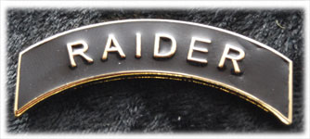
2. Color Guard
Be a member of Color Guard for the entire year and participate in a minimum of 3 Color Guard events.
3. Drill  Be a member of the Drill team for the entire year and only miss a maximum of 2 Drill meets. | 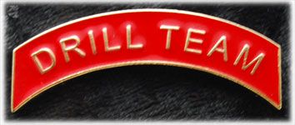
4. Saber Team  Be a member of the Saber team. | 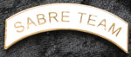
5. Summer Camp  Attended a JROTC summer. | 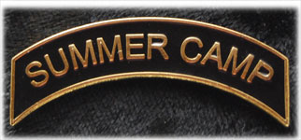
6. JCLC
Attended the JROTC Cadet Leadership Challenge.
7. Flag Detail
Has been involved in a minimum of 5 flag details.
8. Staff  Is a current member of the battalion staff | 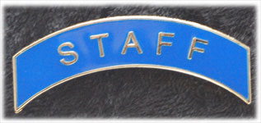
9. Honor Roll  Maintains a grade point average (GPA) of a 3.5 or higher | 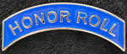

9.8 Shoulder Chords

1. Raider Team Chord
Was a member of the Raider team for an entire season
2. Color Guard Chord
Was a member of the Color Guard for an entire season and has completed a minimum of 3 Color Guard events
3. Drill Team Chord
Was a member of the Drill Team for an entire season
4. Staff Chord
Is a current member of the battalion staff e.g. (S-1, S-2, S-3, S-4, S-5)

9.9 Unit Merit Devices

1. Honor Unit with Distinction
Each member of a unit designated as an Honor Unit with Distinction will be awarded the Honor Unit with Distinction Insignia (Yellow Star)
2. Honor Unit
Each member of a unit designated as an Honor Unit will be awarded the Honor Unit Insignia (Blue Star)

3. Merit Unit
Each member of a unit designated as a Merit Unit will be awarded the Merit Unit Insignia (White Star).

Section X
General Knowledge

  - Cadet Position and Rank

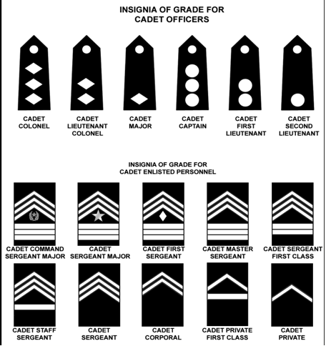

  - Cadet Creed

  - I am an Army Junior ROTC Cadet. I will always conduct myself to bring credit to my family, country, school and the Corp of Cadets. I am loyal and patriotic. I am the future of the United States of America. I do not lie, cheat or steal and will always be accountable for my actions and deeds. I will always practice good citizenship and patriotism. I will work hard to improve my mind and strengthen my body. I will seek the mantle of leadership and stand prepared to uphold the Constitution and the American way of life. May God grant me the strength to always live by this creed.

  - Preamble of the Constitution

  - We the people of the United State of America in order to form a perfect union establish justice, insure domestic tranquility, provide for the common defense, and promote the general welfare, and secure the blessing of liberty to ourselves and our prosperity do ordain and establish this constitution of the United States of America.

  - Chain of Command
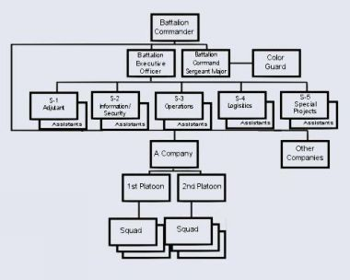

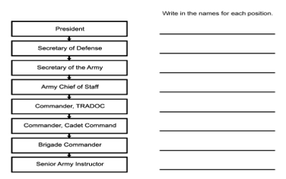

  - JROTC Courtesy

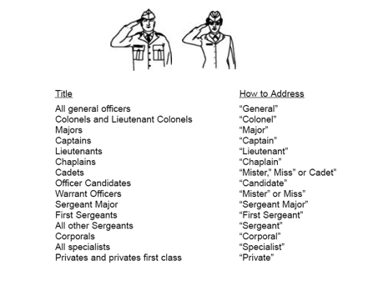

When speaking to an Officer cadet, you may also respond with “Sir” or “Ma’am”
I. When do you salute?
- When you hear the National Anthem, To the Colors, and Hail to the Chief
- When the National Colors or Standard passes by
- On ceremonial occasions
- In all official greetings
- At reveille, within sight of the flag or sound of the music
- During the rendering of Honors
- When passing by uncased colors out of doors
- When reporting to a board
- When reporting to an officer
- When Pledging Allegiance

  - How to Properly Fold the Flag

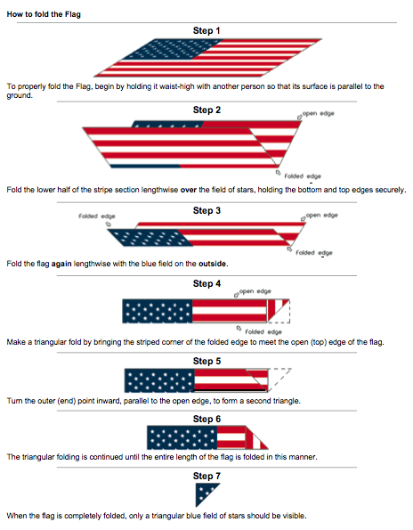

  - Cadet Boards

I. How to Report to the Board and What to do During the Board

1. Reporting to the Board
A. Knock loudly on the door of the board room and enter when told to do so.
B. Approach the president of the board using proper facing movements and
position yourself 3 steps in front of the president of the board.
C. Halt at attention, render a hand salute, and report to the president of the
board as follows: "Sir," or "Sergeant, Cadet (Smith) reports. Hold your salute until the president returns it. This is the proper way to report.
D. If being seated, look over shoulder, step to the rear with your left foot, and
be seated. While seated, sit straight with both feet flat on the floor and
approximately one foot apart. Place your hands, fingers outstretched, but
comfortable, on your knees or thighs
  - Opening statement
A. Be prepared to give a brief summation of your cadet career. Include
positions held, jobs performed, education, and significant
accomplishments. Do not try to memorize dates.
B. Be clear and concise, and use this as an opportunity to relax. Address the
President, looking directly at him, and at least once, look directly at all
board members during the your opening statement.
3. Answering the Board Member’s Questions
      - Do your best not to show nervousness and listen very carefully to questions being directed at you. Begin all statements to the board members by title with "Sergeant Major," "First Sergeant," "Sergeant," or with whatever salutation is appropriate.
      - Speak loudly enough so that all board members will hear you and distinctly enough so that you will not be misunderstood. If you feel your voice start to waiver because of nervousness, raising your voice will help to steady it.
      - Direct your answer to the person asking the question, maintaining eye-to-eye contact at all times.
      - Don’t give answers you do not know or try to fake an answer. If you do not know an answer, simply say "Title of board member (i.e., Sergeant Major, etc.), I do not know the answer. If you do not understand the question, ask the board member to please repeat or rephrase it.
      - Don’t mumble or begin your reply with "uh", "oh", "I think", or "I believe". This indicates indecisiveness. Never say, "I’m sorry", if you don’t know the answer. It is helpful and impressive to repeat the question as part of your answer. For example, "Sergeant, the five colors of the map are...”
      - When asked your opinion, be sure it is your opinion. Board members do not penalize you for an opinion they do not agree with. They only want to evaluate your knowledge, speaking ability, and ability to intelligently present an opinion.
4. Departing the Board
A. Come to attention in front of the board president.
B. Render a hand salute to the president of the board and hold your salute
until it has been returned.
C. Leave the room using proper facing movements and close the door unless
directed otherwise.

  - Weekly Inspection Assessment Reports
As part of the duties of Company Commander and First Sergeant, you are responsible for writing weekly Inspection Assessment reports (can be typed or written neatly). Bellow is an example of the assessment report sheet and the criteria necessary.
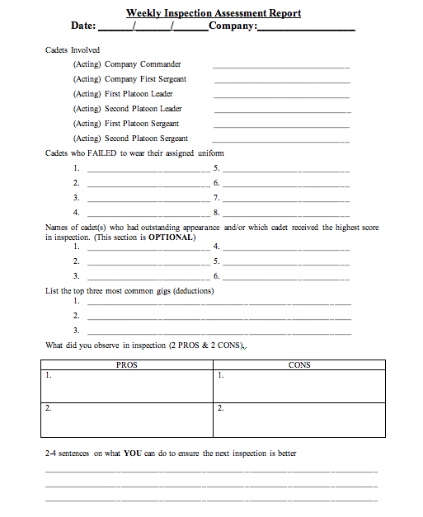

  - Names of those involved in inspection (PLT Leaders, PLT Sgt, CDRs, & 1SGs).
  - Names of cadets who did not dress out for inspection.
  - Names of cadet(s) who had outstanding appearance and/or which cadet received the highest score in inspection (This section is OPTIONAL).
  - List the top three most common gigs (deductions).
  - What did you observe in inspection? (2 PROS & 2 CONS)
  - 2-4 sentences on what YOU can do to ensure the next inspection is better.

