JROTC
MASTER SERGEANT
EXAM STUDY GUIDE
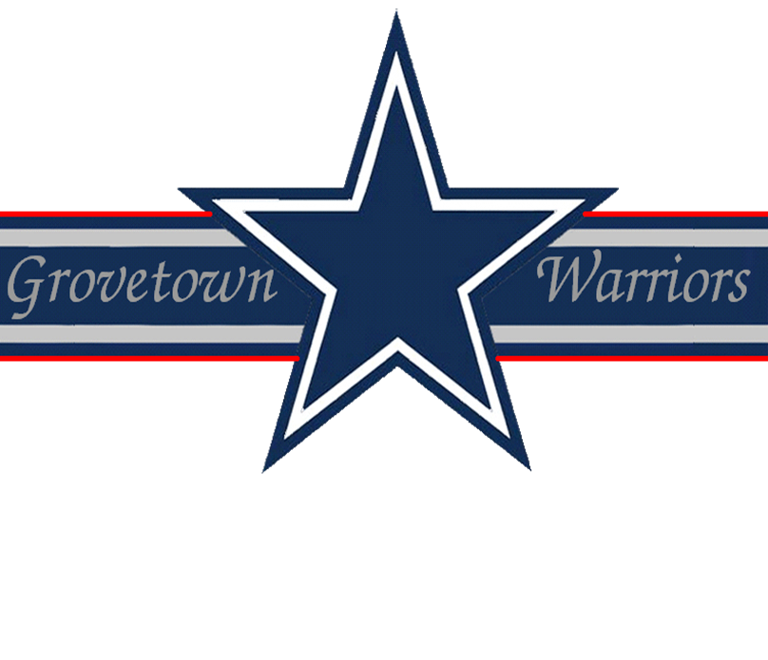

Drill & Ceremonies
1. You are marching troops, you have given the command of AT EASE, MARCH, you approach a smooth level area, how do you get the troops back in step?
Give the command QUICK TIME, MARCH and count cadence for eight steps.
2. What are the rest positions from the halt?
- Parade rest - it may be given from the command of attention only
- Stand at ease - it may be given from the command of attention or parade rest
- At ease - it may be given from the command of attention, parade rest stand at ease, or rest
- Rest - it may be given from the command of attention, parade rest, stand at ease, or at ease
3. What command is given to align the squad, platoon, or other element?
To align a squad, platoon, or other element at normal intervals, the commands are DRESS RIGHT, DRESS and READY, FRONT with the command of execution being DRESS and FRONT.
4. Why do we have drill and ceremony?
To move units or individuals in a uniform manner with precision, to instill discipline and esprit de corps, to render honors, and to preserve tradition.
5. Which foot do you turn on when executing rear march?
You pivot on the balls of both feet.
6. What is the definition of parade rest, stand at ease, at ease, and rest?
These are all rest positions at the halt.
7. How do you close ranks?
On the command close ranks, march, the first rank takes four 15 inch steps to the rear, the second rank takes two 15 inch steps to the rear, the third rank remains in place, and the fourth rank takes one 30 inch step forward.
8. What is the post for the guidon bearer in a company mass formation when the commander is present?
Two 15-inch steps to the rear and two 15-inch steps to the left of the commander.
9. The platoon leader commands a column formation, FILE FROM THE RIGHT, what are the supplementary commands for the squad leaders?
Fourth squad leader commands FORWARD while the other squad leaders give the command STAND FAST.
10. What is meant by the term "post"?
Post refers to the correct place for an officer or noncommissioned officer to stand in a prescribed formation.
11. How would you dismiss a formation of unarmed troops?
Give the command DISMISSED.
12. What command do you give when changing direction and a column movement is not applicable?
INCLINE AROUND LEFT (RIGHT).
13. In which directions, for short distances only, may the unit commander have the unit move in a designated number of steps?
Forward or backward or sideways.
14. In what position is the individual soldier in when executing the manual of arms while at the halt?
Order Arms or Sling Arms.
15. Define a column.
A formation in which the elements are one behind the other.
First Aid
1. When must mouth to nose respiration be used?
Mouth to nose respiration must be used when the casualty has a severe mouth or jaw wound or when the jaws are tightly shut by muscle spasms.
2. What is the purpose of splinting and why?
To immobilize or fix bone fragments. Broken fragment may cause blood vessel and nerve damage which may lead to shock and increased pain.
3. What are the five signs of a fracture?
- Bone protruding through the skin
- Unnatural position
- Tenderness or pain when slight pressure is applied
- Swelling of the injured area
- Discoloration of the skin at the injury
4. What equipment can be used as a splint?
Rifles, boards, tree limbs, or anything flat.
5. How should a patient with a fractured spine be transported?
Soldier should be transported on a litter or a straight board maintaining the natural arch in the back.
6. When should a patient not be placed in the shock position?
When the patient has a head injury.
7. What is the minimum amount of ties used in immobilizing a limb?
Four ties, minimum, 2 above and 2 below the fracture.
8. Name two important things you shouldn’t do when treating a person with abdominal wounds.
- Touch or try to push protruding organs into the wound
- Apply dressing or bandages too tightly because it can cause additional injury
9. In what position do you place a casualty with a stomach wound?
On his back with his knees flexed.
10. To stop bleeding, should pressure be applied between the wound and heart, or between the wound and end of the extremity?
Between the wound and the heart.
11. What is found in the first aid packet that each individual carries?
Field dressing.
12. What does the word "hemorrhage" mean?
Excessive bleeding.
13. What are three types of classification of burn and describe?
- 1st degree: reddening of the skin
- 2nd degree: blistering
- 3rd degree: charred flesh.
14. What is the amount of water given a person suffering from heat stroke or heat exhaustion?
Slowly drink at least one canteen full of water.
15. What are the two types of frostbite?
- Superficial
- Deep
Flags, Guidons, Streamers, Automobile and Aircraft Plates
1. What are the names, sizes and occasions for the display of the Flag of the United States?
- Garrison: 20 ft x 38 ft; flown on Holidays and other important occasions as designated by Presidential Proclamation
- Post: 8 ft and 11 3/8 in x 17 ft; flown daily
- Field: 6ft 8 in x 12 ft; displayed with the Positional Flag
- Storm: 5ft x 9ft 6in; flown in inclement weather
- Internment: 5ft x 9ft 6in; for deceased military personnel and veterans
- Grave Decoration: 7 in x 11 in
2. When can the flag be flown upside down?
Only in time of National Distress or in an emergency.
3. How is the National Flag lowered from the half-mast position?
The flag is raised to the top of the mast and then lowered.
4. Who is responsible to ensure that National Flags on display are presentable?
Commanders.
5. What is the height of the flag pole on which the National Flag is flown?
The height will be fifty (50), sixty (60), or seventy-five (75) feet.
6. How is the flag displayed on the casket of a deceased military person?
The union is at the head and over the left shoulder.
7. Is the flag lowered into the grave?
No.
8. What is another name given to the blue field of our flag?
The Union.
9. In a parade, where are the organizational colors carried?
Always to the left of the national colors.
10. What are the four colors of the Army Flag?
Scarlet, Blue, White, & Yellow.
Leadership Counseling
1. What is directive counseling?
When the counselor assumes the dominant role.
2. What are the reasons for counseling?
Reception and Integration, Discipline, Performance, Professional Growth and Guidance, and Personal.
3. What DA Form is used for counseling?
DA Form 4856-R, General counseling form.
4. What is Active Listening?
Active listening involves concentrating on what the soldier is saying and letting him know that he is being heard and understood.
5. What are the leader follow-up measures?
- Let the chain of command know the results of the counseling
- Take action or make referrals agreed upon during the counseling
- Continue to evaluate the situation
- Recognize positive results
- Take corrective measures for poor results
Map Reading
1. What is a map?
A map is a graphic representation, drawn to scale, of a portion of the earth’s surface.
2. Why is it necessary to learn to read a map?
- To assist in locating and determining exact locations
- To assist in maintaining direction
- To assist in determining routes to follow
3. What colors are used on military maps?
- Blue: water
- Green: vegetation
- Red-Brown: cultural features, all relief features, and elevation
- Red: main roads and populated areas
- Black: man-made objects
- Brown: relief features & elevation
4. How do you orient a map?
By placing it in a horizontal position with is north pointing to the north.
5. What is dead reckoning?
A technique of following a set route or line for a determined distance.
Military Courtesy
1. Who salutes, when necessary, during a formation?
During a formation, the individual in charge salutes, when necessary.
2. What is tatoo and when is it played?
Tatoo means lights out and quiet in the barracks and is played at 2100 hours.
3. How does the individual report indoors with a rifle?
The individual knocks, does not uncover and enters when to do so carrying the rifle at trail or sling arms. He renders the salute prescribed for the weapon with which he is armed.
4. What should you do when approaching an officer while double-timing alone?
If you approach an officer while you are double-timing alone, assume quick time march and render the hand salute. When the salute is returned, execute order arms and resume double-timing.
5. Who initiates a salute?
The salute is always initiated by the subordinate and terminated only after acknowledgment by the individual being saluted.
Military History
1. What was General Douglas MacArthur’s rank when he retired?
General of the Army.
2. Name three officers who held the rank of General of the Army.
- Douglas MacArthur
- Dwight D. Eisenhower
- Omar Bradley
- George C. Marshall
3. What service is the oldest (Army, Navy or Air Force)?
US Army: established 14 June 1775.
4. How many five star Generals were there and who are they?
- Eisenhower
- Bradley
- MacArthur
- Marshall
- Pershing
5. The resident Commissioner from Puerto Rico is elected to serve how many years?
Four. He takes part in discussions but has no vote.
Military Leadership
1. What are the 23 Traits of Character?
Bearing, Confidence, Courage, Integrity, Decisiveness, Justice, Endurance, Tact, Initiative, Coolness, Maturity, Improvement, Will, Assertiveness, Candor, Sense of humor, Competence, Commitment, Creativity, Self-discipline, Humility, Flexibility, Empathy/Compassion.
2. What are the principle forces you should consider when making an ethical decision?
- Legal standards
- Basic national values
- Traditional Army values
- Actual Army values
- Individual values
- Institutional Pressures
3. What is the danger of too much supervision?
It stifles the initiative, breeds resentment, and lowers morale and motivation.
4. What is tact?
It is a sensitive perception of people, their values, feelings, and views which allows positive interaction..
5. What are ethics?
Rules or standards that guide a individual or a group to do the moral or right thing.
6. How can you, as a leader, influence the beliefs and values of your soldiers?
By setting the example; by rewarding behavior that supports professional beliefs, values, and norms, and by planning and conducting tough individual and collective training.
7. What is communication?
It is the exchange or flow of information and ideas from one person to another.
8. How many motivational principles are there? Give two examples of these.
Fourteen (14):
- Make the needs of individuals in your unit coincide with the unit tasks and missions
- Reward individual and team behavior that support unit tasks and missions
- Counsel or punish soldiers who behave in a way that is counter to unit tasks, missions an standards
- Set the example in all things
- Develop morale and esprit in your unit
- Give your subordinates tough problems and challenge them to wrestle with them
- Have your subordinates participate in the planning of upcoming events
- Alleviate causes of the personal concerns of your soldiers so that soldiers can concentrate on their jobs
- Ensure your soldiers are properly cared for and have the tools they need to succeed
- Keep your soldiers informed about mission and standards
- Use positive peer pressure to work for you and your unit
- Avoid using statistics as a major method of evaluating units and motivating subordinates
- Make the jobs of your subordinates as challenging, exciting and meaningful as possible
- Do not tolerate any form of prejudicial talk or behavior in your unit
9. What are the two types of authority?
Command authority and general military authority.
10. What are the nine leadership competencies?
- Communications
- Supervision
- Teaching and counseling
- Soldier team development
- Technical and tactical proficiency
- Decision making
- Planning
- Use of available systems
- Professional ethics
Physical Fitness
1. What are the seven principals of exercise?
- Progression
- Regularity
- Overload
- Variety
- Recovery
- Balance
- Specificity
2. What groups of soldiers may need special fitness programs?
- APFT failures who do not have medical profiles
- Overweight personnel according to AR 600-9
- Those who have permanent or temporary profiles
3. Who makes rulings on questions or scoring for each event in the APFT?
The event supervisor.
4. May the scorer stand while scoring the push-up event?
No, the scorer must kneel or sit about three feet from the tester’s hip.
5. Is it legal to pace a soldier during the 2-mile run on the APFT?
Yes, as long as there is no contact.

