JROTC SERGEANT FIRST CLASS EXAM STUDY GUIDE
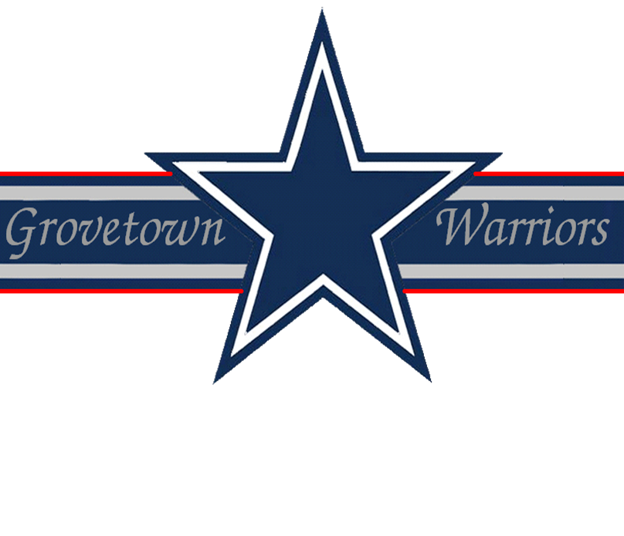

Drill & Ceremonies
1. How many counts does it take to move from order arms to inspection arms?
Seven.
2. On what side of a formation is a guide always positioned in a column formation?
On the right side front corner of formation.
3. What command is given to obtain close interval from normal interval while marching?
CLOSE INTERVAL, MARCH.
4. How do you change a line formation to a column formation?
Give the command RIGHT, FACE.
5. How would you dismiss a company formation of armed troops?
Give the commands:
- INSPECTION, ARMS
- READY, PORT, ARMS
- SLING, ARMS
- ORDER, ARMS
- DISMISSED
6. In which directions, for short distances only, may the unit commander have the unit move in a designated number of steps?
Forward or backward or sideways.
7. At what position does a squad stack arms?
In a line formation at normal interval.
8. What is the first step in stacking arms?
The squad leader commands COUNT, OFF and then designates the stackmen by numbers.
9. What is the length of the arm swing while marching at quick time?
Nine inches to the front, six inches to the rear.
10. How many steps are in half step and how long are the steps?
120 steps per minute with a 15 inch step.
First Aid
1. When you discover an individual’s heart has stopped beating, what action must be taken immediately?
External Chest Compression: One rescuer will perform CPR using a 15 to 2 ratio (15 compressions followed by 2 quick but full long inflations). Two rescuers - 1 compression each second with the second rescuer giving 1 breath every 5 compressions.
2. What is a closed fracture?
A break in the bone without a break in the overlying skin.
3. What are the five signs of a fracture?
- Bone protruding through the skin
- Unnatural position
- Tenderness or pain when slight pressure is applied
- Swelling of the injured area
- Discoloration of the skin at the injury
4. When should a patient not be placed in the shock position?
When the patient has a head injury.
5. What is the minimum amount of ties used in immobilizing a limb?
Four ties, minimum, 2 above and 2 below the fracture.
6. What may result if an unsplinted fracture is moved?
Pain, can increase shock, may further damage nerve, muscles and blood vessels.
7. If a casualty has an open chest wound, after the wound is bandaged air-tight, should he be allowed to sit up if he is more comfortable?
Yes.
8. If a casualty with an open chest wound chooses to lie down after the wound is air-tight, which side should he lie on?
His injured side.
9. What preventive measures can be taken to prevent heat injuries?
Drinking plenty of water.
10. Name three types of bleeding.
- Arterial
- Venous
- Capillary
11. If you have a severe cut on the inside of your wrist, which is bleeding badly, where would you apply a tourniquet?
Directly above the elbow.
12. What are the symptoms and treatment for heat exhaustion?
Symptoms:
- Loss of appetite
- Headache
- Excessive sweating
- Weakness or faintness
- Dizziness
- Skin is pale, cool, moist and clammy
Treatment: Move to a cool, shady area or improvised shade, loosen clothing, pour water on him and fan him, have casualty slowly drink at least one full canteen of water, elevate casualty’s legs, seek medical aid if symptoms continue.
13. Where should a deep frostbite be treated?
At the aid station.
14. What are some of the most common causes of blisters and abrasions?
Ill-fitting footwear and socks, improperly maintained footwear and heat and moisture
15. How do you treat a casualty for a severe electrical shock?
Treatment for severe electrical shock is to turn off the power, if possible; use a dry wooden pole or any other non-conductive material to remove the casualty from the live wire; administer artificial respiration, if required; and send for medical aid.
Flags, Guidons, Streamers, Automobile and Aircraft Plates
1. How are the stars arranged on the flag?
Four (4) rows of five (5) and five (5) rows of six (6)
2. How is the flag displayed on the casket of a deceased military person?
The union is at the head and over the left shoulder.
3. What do we mean by the flag is "cased"?
When inserted in a special canvas cover.
4. How is the United States Flag displayed in a rostrum or stage?
It will be placed above and behind the speakers stand.
5. What do the red and white stripes of our flag stand for?
The thirteen original colonies.
6. What three places is the American Flag flown at half-mast at all times?
- Arlington National Cemetery
- Tomb of the Unknown Soldier
- USS Arizona Battleship at Pearl harbor
7. What are some of the legal holidays when the Garrison Flag is displayed (weather and military operations permitting)?
- New Year’s Day (1 January)
- Washington’s Birthday (22 February)
- Memorial Day (30 May)
- Independence Day (4 July)
- Labor Day (lst Monday in September)
- Columbus Day (2nd Monday in October)
- Veterans Day (11 November)
- Thanksgiving Day (4th Thursday in November)
- Christmas Day (25 December)
8. What is the difference between a Flag, Colors, and a Standard?
- The Flag is the emblem of our country and displayed on flag poles at Post and other Headquarters authorized to display them
- The Colors is the flag when carried in formation by dismounted troops
- The Standard is the flag when carried in formation by mounted or mechanized troops
9. In a parade, where are the organizational colors carried?
Always to the left of the national colors.
10. Who is authorized a Distinguished Flag, Boat Flag, and Automobile Flag?
- Flag officers in the rank of Brigadier General and above
- Civilian officials of cabinet rank (e.g., Secretary of Defense)
Leadership Counseling
1. What manual pertains to Leadership Counseling?
Field Manual 22-101.
2. What type of personal counseling is most effective?
Personal counseling which encourages the person to arrive at their own solution.
3. What should you do with information concerning a criminal act obtained during a counseling session in confidence?
A leader who gains information concerning a criminal act during counseling has a responsibility to report it to the proper authorities. The counselee has a right to be informed of this limitation on confidentiality before session reveals possible criminal activity.
4. What is performance counseling?
Performance counseling is the process of communicating to a subordinate the leader’s assessment of the strong aspects of the subordinate’s performance of duty and ways in which that performance may be improved.
5. What are the leader follow-up measures?
- Let the chain of command know the results of the counseling
- Take action or make referrals agreed upon during the counseling
- Continue to evaluate the situation
- Recognize positive results
- Take corrective measures for poor results
Map Reading
1. What colors are used on military maps?
- Blue: water
- Green: vegetation
- Red-Brown: cultural features, all relief features, and elevation
- Red: main roads and populated areas
- Black: man-made objects
- Brown: relief features & elevation
2. What are the symbols for the three norths?
- Magnetic: Arrow
- True: Star
- Grid: Vertical Line
3. What is the legend of a map?
Illustrates and identifies the topographic symbols used to depict the more prominent features of the map.
4. What is modified resection?
The method of locating one’s position on the map when the person is located on a linear feature on the ground, such as a road or canal.
5. What are the three field expedient methods of determining direction?
- Shadow tip method
- Watch method
- Star method
Military Courtesy
1. Who leaves a military vehicle first?
The most senior member.
2. Is an officer required to return a hand salute?
Yes. except when he is pay officer.
3. Does a unit resting along the road come to attention and salute an approaching officer?
No.
4. Who was the first military commander to lead troops under the flag of the United Nations?
General Douglas MacArthur.
5. The Secretary of Defense receives how many gun salute?
The Secretary of Defense receives a 19 gun salute.
6. Describe the actions of the individual in charge of a group of troops riding in a military vehicle when the National Anthem is played.
When riding in a military vehicle and the National Anthem is heard, the vehicle pulls over to the side. The individual in charge dismounts and renders the hand salute; persons in the vehicle will sit at the position of attention.
7. What is tatoo and when is it played?
Tatoo means lights out and quiet in the barracks and is played at 2100 hours.
8. At 1200 hours on 4 July, a salute to the union is rendered in commemoration of the Declaration of Independence. What does this salute consist of?
At 1200 hours on 4 July, a salute to the union is rendered in commemoration of the Declaration of Independence consisting of a gun salute with the amount of guns fired equal to the amount of states in the union.
9. When do you salute in formation?
Salute only on command when in formation.
10. What actions should be taken when in a group and an officer approaches?
If in a group and an officer approaches, the first soldier to recognize the officer calls the group to attention and all personnel salute.
Military History
1. Who wrote the first field manual on Drill and Ceremonies?
Major General Baron Von Steuben.
2. Which has the largest population, North or South Korea?
South Korea.
3. What does SOFA stand for?
Status of Forces Agreement.
4. The first field manual was entitled, "The Regulations for the Order and Discipline to the Troops of the United States", and commonly known as the Blue Book. When and why was it written?
Written in 1779 to ensure continuity and uniformity of discipline in the US Army.
5. Who was the first person to be assigned a serial number?
General Pershing.
Military Leadership
1. What are the factors of leadership?
The Led, the Leader, the situation, and communications.
2. What are some of the pressures to be unethical?
- Pressure from self-interest
- Pressure from peers
- Pressure from subordinates
- Pressure from a senior
3. What are values?
Values are attitudes about the worth or importance of people, concepts or things.
4. What are beliefs?
Beliefs are assumptions or convictions that an individual knows to be true regarding people, concepts or things.
5. How many motivational principles are there? Give two examples of these.
Fourteen (14):
- Make the needs of individuals in your unit coincide with the unit tasks and missions
- Reward individual and team behavior that support unit tasks and missions
- Counsel or punish soldiers who behave in a way that is counter to unit tasks, missions an standards
- Set the example in all things
- Develop morale and esprit in your unit
- Give your subordinates tough problems and challenge them to wrestle with them
- Have your subordinates participate in the planning of upcoming events
- Alleviate causes of the personal concerns of your soldiers so that soldiers can concentrate on their jobs
- Ensure your soldiers are properly cared for and have the tools they need to succeed
- Keep your soldiers informed about mission and standards
- Use positive peer pressure to work for you and your unit
- Avoid using statistics as a major method of evaluating units and motivating subordinates
- Make the jobs of your subordinates as challenging, exciting and meaningful as possible
- Do not tolerate any form of prejudicial talk or behavior in your unit
Physical Fitness
1. What are the seven principals of exercise?
- Progression
- Regularity
- Overload
- Variety
- Recovery
- Balance
- Specificity
2. Why are ability group runs more effective than a unit formation run?
An ability group run allows soldiers to train in groups of soldiers with near ability. Each group runs with the intensity to produce a training effect for that group.
3. May the scorer stand while scoring the push-up event?
No, the scorer must kneel or sit about three feet from the tester’s hip.

