JROTC
SERGEANT
EXAM STUDY GUIDE
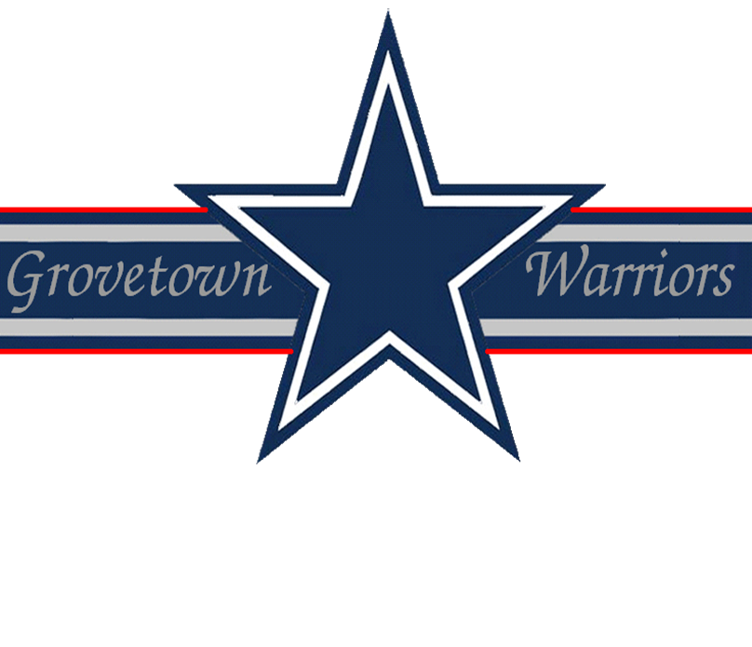

Drill & Ceremonies
1. What command is given to turn the element 90 degrees to the left or right while marching?
LEFT or RIGHT FLANK MARCH.
2. What command is given for marching backwards?
BACKWARD, MARCH.
3. From order arms, how many counts does it take to move to port arms?
Two.
4. What command is given to align the squad, platoon, or other element?
To align a squad, platoon, or other element at normal intervals, the commands are DRESS RIGHT, DRESS and READY, FRONT with the command of execution being DRESS and FRONT.
5. How many counts does it take to execute facing to the flank from the halt?
Two.
6. What are the two prescribed formations for a squad?
- Squad line
- Squad column
7. Define a file.
A column which has only one element at its front.
8. What is the prescribed publication for Drill and Ceremonies?
Field Manual 22-5.
9. During "MARK TIME", how many inches should the feet be lifted?
Two inches.
10. What is a step?
The measured distance from heel to heel of a marching element.
First Aid
1. What is the most effective method of preventing disease?
Cleanliness.
2. What is the best way to give artificial respiration?
Mouth to mouth artificial respiration.
3. What is a fracture?
A broken bone.
4. If pressure has been applied to a bleeding wound and the bleeding wound doesn’t stop, what method should you use in stopping the bleeding?
Tourniquet.
5. When treating for or trying to prevent shock, you are suppose to give the casualty, provided he is awake and does not have a belly wound, a stimulant. Would you consider alcohol a stimulant?
No, it’s a depressant.
6. Name three types of bleeding.
- Arterial
- Venous
- Capillary
7. What is found in the first aid packet that each individual carries?
Field dressing.
8. What does the word "hemorrhage" mean?
Excessive bleeding.
9. After a tourniquet is used to stop bleeding, who is authorized to remove it?
A doctor or medically qualified person.
10. What are the two types of frostbite?
- Superficial
- Deep
Flags, Guidons, Streamers, Automobile and Aircraft Plates
1. How many stripes does the flag have and how are they arranged?
13 stripes, 7 red and 6 white, the first and las111111111111t stripes are red.
2. What are the three (3) other names used in the military services for the flag?
- Colors: flag carried by dismounted troops, Supreme Commanders, and certain General Officers
- Standard: flag carried by mounted or motorized units
- Ensign - flag flown on ships, small boats, and airships
3. What is known as the mast?
The flagpole.
4. How is the flag removed from a casket of a deceased military person and what is its disposition?
It is carefully folded into a triangle with the union up and presented to the next of kin.
5. When did we begin to use the 50 star flag?
4 July 1960.
Leadership Counseling
1. Is performance counseling limited to bad performance?
No, counseling should be for good performance as well.
2. What type of personal counseling is most effective?
Personal counseling which encourages the person to arrive at their own solution.
3. What are the five steps in preparing to counsel?
- Notify the soldier
- Schedule the best time
- Choose a suitable place
- Decide the right atmosphere
- Plan the discussion
4. What is Active Listening?
Active listening involves concentrating on what the soldier is saying and letting him know that he is being heard and understood.
5. What is the key to getting results from counseling?
Performing leader follow-up measures.
Map Reading
1. What does the color yellow represent on an overlay?
A contaminated area.
2. What are three norths on a military map?
- Magnetic
- True
- Grid
3. How can you identify the map you want to use?
By sheet name and numbers.
4. What is a military symbol?
Graphic aids which accurately identify items of operational interest.
5. What is a NEAT line?
It is the outer line of a map that you align other maps with.
Military Courtesy
1. When is a military member not required to salute?
When he is a prisoner.
2. How is a member of the armed service addressed when the rank is not known?
Soldier.
3. How many gun salutes is the Commander in Chief entitled to?
On arrival - 21; on departure – 21.
4. If you are in a vehicle and see an officer. Who renders the hand salute?
If in a vehicle, the front right hand passenger will render a hand salute to an officer passing by.
5. What is "To The Colors?"
"To The Colors" is the Old Cavalry Call "To the Standard", in use from about 1835.
6. Do you normally salute indoors?
No, you do not normally salute indoors
7. The Secretary of Defense receives how many gun salute?
The Secretary of Defense receives a 19 gun salute.
8. Why should you salute proudly?
You should salute proudly because it shows you have pride in yourself and your outfit and that you have confidence in your abilities as a soldier.
9. Who salutes, when necessary, during a formation?
During a formation, the individual in charge salutes, when necessary.
10. Who wrote the "Star Spangled Banner"?
The "Star Spangled Banner" was written by an American POW, Francis Scott Key, of Baltimore, Maryland on 14 September 1814 during the British bombardment of Fort McHenry.

Military History
1. Who was the first General to lead an American Army?
General George Washington.
2. What is the date 7 December l941 known for?
The Japanese unprovoked attack at 0730 hours on Pearl Harbor.
3. What service is the oldest (Army, Navy or Air Force)?
US Army: established 14 June 1775.
4. When was the Constitution of the United States written?
1787.
5. What does the Congress of the United States consist of?
- Senate
- House of Representatives (A resident Commissioner of Puerto Rico serves also)
Military Leadership
1. What are the three types of duties that each NCO has?
- Specified duties
- Directed duties
- Implied duties
2. Name three factors which tend to shape personality.
Heredity, Environment, Experience.
3. What is morale?
Morale is the mental, emotional, and spiritual state of mind of an individual. It is how a soldier feels. High morale strengthens courage, energy and the will to fight.
4. What is Esprit?
Esprit is the spirit, the soul, and the state of mind of a unit that the soldier identifies with.
5. What is bearing?
An individual’s posture, overall appearance and manner physical movement. It is an outward display to others of the state of your inner feelings, fear and overall inner confidence.
6. What is integrity?
It is the utter sincerity, honesty and candor. It is the avoidance of any kind of deceptive, shallow, or expedient behavior.
7. What is an unselfish leader?
One who avoids providing for his own comfort and advancement at the expense of others.
8. What are some of the pressures to be unethical?
- Pressure from self-interest
- Pressure from peers
- Pressure from subordinates
- Pressure from a senior
9. What is military leadership?
Military leadership is the process of influencing others to accomplish the mission by providing purpose, direction, and motivation.
10. What manual pertains to Military Leadership?
Field Manual 22-100.
Physical Fitness
1. What are the four FITT factors?
- Frequency
- Intensity
- Time
- Type
2. May the event supervisor for an event on the APFT also be a scorer?
No.
3. What does the push-up measure?
Endurance of the chest, shoulder, and triceps muscles.
4. May the scorer stand while scoring the push-up event?
No, the scorer must kneel or sit about three feet from the tester’s hip.
5. Is it legal to pace a soldier during the 2-mile run on the APFT?
Yes, as long as there is no contact.

