JROTC
STAFF SERGEANT
EXAM STUDY GUIDE
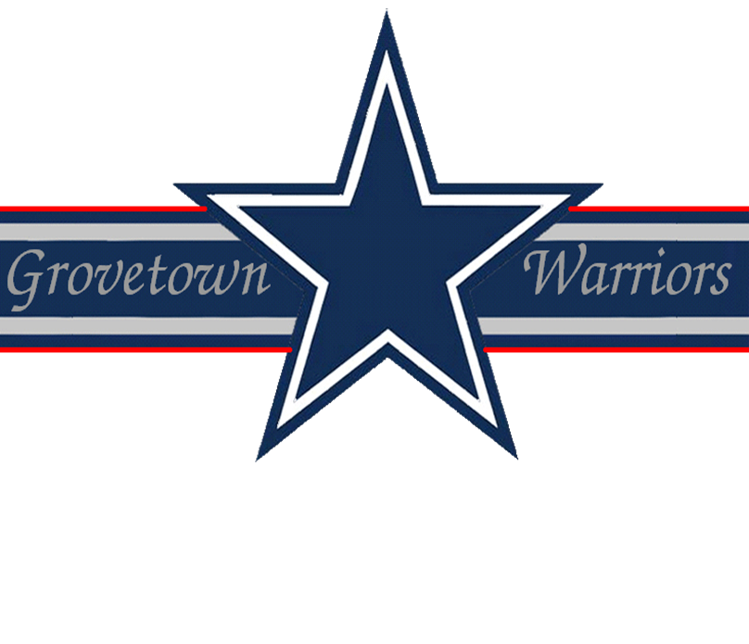

Drill & Ceremonies
1. You are marching troops, you have given the command of AT EASE, MARCH, you approach a smooth level area, how do you get the troops back in step?
Give the command QUICK TIME, MARCH and count cadence for eight steps
2. What are the rest positions from the halt?
- Parade rest - it may be given from the command of attention only
- Stand at ease - it may be given from the command of attention or parade rest
- At ease - it may be given from the command of attention, parade rest stand at ease, or rest
- Rest - it may be given from the command of attention, parade rest, stand at ease, or at ease
3. What command is given to align the squad, platoon, or other element?
To align a squad, platoon, or other element at normal intervals, the commands are DRESS RIGHT, DRESS and READY, FRONT with the command of execution being DRESS and FRONT.
4. When is the command halt given while doing the left step?
When heels come together.
5. When marching to the flank, the preparatory command for a right flank is given when which foot strikes the ground?
The right foot.
6. What command is given to retrieve stacked arms?
TAKE, ARMS.
7. How many steps are in quick time and how long are the steps?
120 steps per minute with a 30-inch step.
8. If a ranking officer enters the mess hall, what action do you take?
Call AT EASE and remain seated.
9. During "MARK TIME", how many inches should the feet be lifted?
Two inches.
10. What is a step?
The measured distance from heel to heel of a marching element.
First Aid
1. What is the ratio of heart compressions to breaths when administering CPR using the one-rescuer method?
15 to 2 Ratio - 15 heart compressions followed by 2 quick but full lung inflations. This cycle is repeated (15:2) 4 times, then check the casualty for breathing and pulse.
2. What equipment can be used as a splint?
Rifles, boards, tree limbs, or anything flat.
3. If you have a major eye injury, which eye should be bandaged?
Both.
4. If a casualty has an open chest wound, after the wound is bandaged air-tight, should he be allowed to sit up if he is more comfortable?
Yes.
5. Should a casualty with an abdominal wound be allowed to drink water or eat anything?
No.
6. Name the four methods used to stop bleeding.
- Pressure dressing (the preferred method)
- Field dressing
- Manual pressure
- As a last resort, tourniquet
7. What are the three types of blood vessels?
Veins, arteries and capillaries.
8. Describe the appearance of bleeding from a vein.
Dark red and a steady flow.
9. What is a dressing?
A sterile pad, compress or sponge applied directly to a wound for the promotion of healing.
10. What are the five steps in treating a blister?
- Wash the area with soap and water
- Sterilize a needle by heating until red
- Puncture the outside edge as close to the lower edge as possible
- Roll the needle from the top edge to the bottom edge draining the blister of any fluid
- Apply and secure a compress dressing
Flags, Guidons, Streamers, Automobile and Aircraft Plates
1. When can the flag be flown upside down?
Only in time of National Distress or in an emergency.
2. Is the flag lowered into the grave?
No.
3. What are some of the legal holidays when the Garrison Flag is displayed (weather and military operations permitting)?
- New Year’s Day (1 January)
- Washington’s Birthday (22 February)
- Memorial Day (30 May)
- Independence Day (4 July)
- Labor Day (lst Monday in September)
- Columbus Day (2nd Monday in October)
- Veterans Day (11 November)
- Thanksgiving Day (4th Thursday in November)
- Christmas Day (25 December)
4. How many campaign streamers does the US Army Flag have?
173.
5. When are Guidons displayed?
Guidons will be carried by units participating in parades and reviews or displayed as directed by the Commander.
Leadership Counseling
1. What are some nonverbal signs that a soldier may be in need of counseling?
- A good performer consistently begins to perform below par
- A normally attentive person suddenly displays a lack of attentiveness of concentration
- A soldier performs deliberate acts of misconduct or refuses to follow instructions or orders
- A normally outgoing soldier becomes withdrawn and a loner
- The soldier’s general appearance is not in compliance with standards
2. What should you do with information concerning a criminal act obtained during a counseling session in confidence?
A leader who gains information concerning a criminal act during counseling has a responsibility to report it to the proper authorities. The counselee has a right to be informed of this limitation on confidentiality before session reveals possible criminal activity.
3. Is it an absolute requirement that leaders regularly counsel their soldiers?
Yes. The leader who neglects to counsel his subordinates is negligent in his performance of duty.
4. Is extra training punishment?
No, when effectively utilized, extra training corrects deficiencies related to inefficiency rather than misconduct. Improved performance is the goal. It requires concerned and caring leadership.
5. What are the leader follow-up measures?
- Let the chain of command know the results of the counseling
- Take action or make referrals agreed upon during the counseling
- Continue to evaluate the situation
- Recognize positive results
- Take corrective measures for poor results
Map Reading
1. What is a map?
A map is a graphic representation, drawn to scale, of a portion of the earth’s surface.
2. Why is it necessary to learn to read a map?
- To assist in locating and determining exact locations
- To assist in maintaining direction
- To assist in determining routes to follow
3. How do you orient a map?
By placing it in a horizontal position with is north pointing to the north.
4. Why are colors used on a map?
To facilitate the identification of features on a map, the topographical and cultural information.
5. What are the 5 major and 5 minor terrain features found on a military map?
- Major: hill; saddle; valley; ridge; depression
- Minor: Draw; spur; cliff; cut; fill
Military Courtesy
1. What is meant by military courtesy?
Military courtesy is the respect and consideration shown to others.
2. What should you do when the National Anthem of a foreign country is played?
Come to attention and salute.
3. At what distance do you normally salute an officer?
Normally within six (6) paces, but can be recognized distance and saluted.
4. When do you salute inside a building?
When you are called to report, when rendering honors, or reporting for pay.
5. What do you do when in doubt of saluting?
Salute.
6. Who is entitled to a salute?
Persons entitled to a salute are all commissioned officers and warrant officers, male and female. It is also customary to salute the officers of allied nations when you recognize them as such.
7. When reporting. who salutes first, the person reporting or the person reported to?
When reporting, the person reporting is required to salute first.
8. How is the salute rendered by sentries posted with a rifle?
The salute is rendered from the HALT and when armed with a rifle, PRESENT ARMS is rendered.
9. When outdoors and you meet an officer, when should you salute?
Salute as soon as you recognize that he or she is an officer (when approximately six steps away).
10. Are salutes required to be rendered by or to personnel who are driving or ridding in privately owned vehicles?
No.
Military History
1. Who won the Korean Conflict?
No one, an Armistice was declared.
2. What does SOFA stand for?
Status of Forces Agreement.
3. What Article designates the creation of the Congress of the United States?
Article 1 of the Constitution.
4. What is the composition of the Senate?
• Composed of 100 members, 2 from each state
• Elected to serve a six (6) year term
5. How many members are in the House of Representatives?
The House of Representatives has 435 members. The number representing each state is determined by population, but every state is entitled to at least one.
Military Leadership
1. What is justice?
It is the fair treatment of all people regardless of race, religion, color, sex, age, or national origin.
2. What is the meaning of the term Military Discipline?
The prompt and effective performance of duty in response to orders or taking the right action in the absence of orders. A disciplined unit forces itself to do its duty in any situation.
3. What are the principles that help ensure good discipline?
- Ensure norms which contribute to discipline are established and strengthened
- Set high, but realistic, standards in all things that relate to the success of your unit in training and war
- When your standards are not met, analyze the situation and decide on a course of action for handling the situation
4. What four emotions must you, as a leader, inspire in yourself and your soldiers that will combat fear, panic and stress?
Confidence, purpose, meaning, and self-respect.
5. What are the two types of authority?
Command authority and general military authority.
Physical Fitness
1. What are the four FITT factors?
- Frequency
- Intensity
- Time
- Type
2. Who is responsible for training the event supervisors, scorers, and demonstrators for the Army Physical Fitness Test (APFT)?
The OIC or NCOIC.
3. What does the push-up measure?
Endurance of the chest, shoulder, and triceps muscles.
4. If the fingers are not interlocked during a repetition of a sit-up, is the repetition not counted, or is the event terminated?
Only that repetition is not counted.
5. Is it legal to pace a soldier during the 2-mile run on the APFT?
Yes, as long as there is no contact.

